SYDNEY SOUTH PLANNING PANEL - ASSESSMENT REPORT

Panel Reference | PPSSSH-60
DA Number | 55/2021
LGA | Canterbury Bankstown Council
Proposed Development | Construction of three residential flat buildings ranging from five to 10 storeys (144 dwellings) with basement level car parking (163 car parking spaces) communal open space areas, and a new roadway to be dedicated (approximately 1,750sqm) to Council. Torrens title subdivision to create separate parcels for the laneway and the development site, and strata subdivision of the apartments.  This application is an Integrated Development and requires approval from Water NSW under the Water Management Act 2000.
Street Address | 5-9 Croydon Street, Lakemba
Applicant/Owner | Applicant: File Planning and Development Services  Owner/s: Samstone Pty Ltd and Sam Harb Pty Ltd
Date of DA lodgement | 8 February 2021
Number of Submissions | Five (5) Submissions
Recommendation | Approval, subject to conditions of consent
Regional Development Criteria (Schedule 7 of the SEPP (State and Regional Development) 2011 | Part 2.4, Clause 2.19(1) of the SEPP (Planning Systems) 2021 the application is declared as regionally significant development. Schedule 7 includes general development that has a capital investment value of more than $30 million. The proposal has a capital investment value of $43,944,840.00 and therefore falls within this category.
List of all relevant s4.15(1)(a) matters | - Water Management Act 2000  - State Environmental Planning Policy (Planning Systems) 2021  - State Environmental Planning Policy (Resilience and Hazards) 2021  - State Environmental Planning Policy 65 – Design Quality of Residential Apartment Development (SEPP 65)  - State Environmental Planning Policy (Transport and Infrastructure) 2021  - State Environmental Planning Policy 2004 (Building Sustainability Index: BASIX)  - State Environmental Planning Policy (Biodiversity and Conservation) 2021  - Canterbury Local Environmental Plan 2012  - Canterbury Development Control Plan 2012  - Canterbury Development Contributions Plan 2013 (Contributions Plan 2013)  - Draft Consolidated Canterbury Bankstown Local Environmental Plan
List all documents submitted with this report for the Panel’s consideration | - Attachment A – Draft Conditions of Consent  - Attachment B - Architectural plans (Revision C dated 16 May 2022)  - Attachment C – Planner RFI Response Table (18 May 2022)  - Attachment D - Architect RFI Response Table (May 2022)  - Attachment E - Design Verification Statement (dated 16 May 2022)  - Attachment F - Landscape Plan (Revision E dated 16 May 2022)  - Attachment G - Traffic and Swept Path drawings  - Attachment H - Stage 1 Contamination Assessment  - Attachment I - Civil and Stormwater Plans  - Attachment J - Waste Management Plan  - Attachment K - Arborist report.
Clause 4.6 requests | No
Summary of key submissions | - Loss of solar access and privacy for surrounding properties  - Proposed development should comply with LEP controls  - Landscaping and green space should be maximised  - Development not in keeping with surrounding context  - Impacts of traffic congestion and parking from new development
Report prepared by | Kate Bartlett of Planning Studio
Report date | 16 August 2022

Summary of s4.15 matters  Have all recommendations in relation to relevant s4.15 matters been summarised in the Executive Summary of the assessment report? | Yes
Legislative clauses requiring consent authority satisfaction  Have relevant clauses in all applicable environmental planning instruments where the consent authority must be satisfied about a particular matter been listed, and relevant recommendations summarized, in the Executive Summary of the assessment report?  e.g. Clause 4.6 of SEPP (Resilience and Hazards) - Remediation of Land, Clause 4.6(4) of the relevant LEP | Yes
Clause 4.6 Exceptions to development standards  If a written request for a contravention to a development standard (clause 4.6 of the LEP) has been received, has it been attached to the assessment report? | No
Special Infrastructure Contributions  Does the DA require Special Infrastructure Contributions conditions (S7.24)?  Note: Certain DAs in the Western Sydney Growth Areas Special Contributions Area may require specific Special Infrastructure Contributions (SIC) conditions | Not Applicable
Conditions  Have draft conditions been provided to the applicant for comment?  Note: in order to reduce delays in determinations, the Panel prefer that draft conditions, notwithstanding Council’s recommendation, be provided to the applicant to enable any comments to be considered as part of the assessment report | Yes

DA-55/2021 SYDNEY SOUTH PLANNING PANEL ASSESSMENT REPORT

EXECUTIVE SUMMARY REPORT

This matter is reported to the Sydney South Planning Panel as the development application proposes a development that exceeds a capital investment value of $30 million in accordance with Schedule 6(2) of State Environmental Planning Policy (Planning Systems) 2021.
The Development Application (DA) DA-55/2021 seeks development consent for Construction of three residential flat buildings ranging from five to 10 storeys (141 dwellings) with basement level car parking (163 car parking spaces) communal open space areas, and a new roadway to be dedicated (approximately 1,750sqm) to Council. Torrens title subdivision to create separate parcels for the laneway and the development site, and strata subdivision of the apartments.
The development proposes:
- Torrens title subdivision to create two parcels of land:
  - A publicly access laneway with access to the development basement, to be dedicated to Council to improve connectivity (approximately 1750sqm)
  - A development lot (approximately 4617sqm)
- Construction of three (3) residential buildings providing a total of 144 residential apartments:

Building A
- Part 5/7 Storeys with a half lower-ground storey
  - 33 x 2 bedroom apartments
  - 2 x 3 bedroom apartments

Building B
- Part 5/7 storey
  - 6 x 1 bedroom apartments
  - 27 x 2 bedroom apartments
  - 2 x 3 bedroom apartments

Building C
- Part 7/10 storey
  - 7 x studio apartments
  - 6 x 1 bedroom apartments
  - 49 x 2 bedroom apartments
  - 12 x 3 bedroom apartments
- Roof top communal area (200sqm) along the southern side of the building including a landscaped area and fitness area.
- Strata subdivision of the apartments.
- Communal open space (912sqm primary and 199sqm secondary) provided at ground level and through a rooftop terrace (200sqm Building C).
- A two level basement extending below the three buildings accommodating 163 car parking spaces including 13 accessible spaces as well as waste storage rooms for each building.
- A lower ground level within Building A accommodating storage cages and bicycle along with building services and manager’s office.
The application has been assessed against the relevant provisions of Water Management Act 2000, State Environmental Planning Policy 55 – Remediation of Land, State Environmental Planning Policy 65 Design Quality of Residential Apartment Development (SEPP 65), State Environmental Planning Policy (Transport and Infrastructure) 2021, State Environmental Planning Policy (Biodiversity and Conservation) 2021, State Environmental Planning Policy 2004 (Building Sustainability Index: BASIX), State Environmental Planning Policy (Resilience and Hazards) 2021, CLEP 2012, Draft CLEP, and CDCP 2012.
The key matters to be considered by the Sydney South Planning Panel (Panel) are:
- The design seeks variation to the building depth and length, and visual privacy requirements contained within the Apartment Design Guide.
- The design seeks variation to the controls relating to basement location, deep soil and landscaping, building setbacks, and building depth and length requirements outlined within the site specific provisions in Part F, CDCP 2012.
- For the reasons outlined within the report, the abovementioned variations are considered acceptable, on merit in the circumstances of this case.
The application was advertised twice throughout the duration of the development assessment process for a period of 28 days consistent with the Canterbury Bankstown Community Participation Plan. The advertising dates are provided below:
- Between 24 February to 24 March 2021 - five submissions were received during this period.
- 15 December 2021 – 2 February 2022 – five submissions were received during this period.
POLICY IMPACT
This matter has no direct policy implications.
FINANCIAL IMPACT
This matter has no direct financial implications.
RECOMMENDATION
It is recommended the Sydney South Planning Panel approve Development Application No. DA-55/2021, subject to the recommended conditions of consent provided in a separate attachment (refer to Attachment A).

SITE & LOCALITY DESCRIPTION

The lots that form part of this proposal are:

- Lot B DP 365853
- Lot A DP 357959
- Lot B DP357959
- Lot 2 DP971844
- Lot 1 DP974686
- Lot A1 DP 372287

The site is an irregular parcel of land with a total site area of 6,367sqm. The site is located in Lakemba, in the Canterbury Bankstown Local Government Area. The site is currently vacant and clear of any vegetation with the exception of small exotic shrubs.

The subject site is located within the Croydon Street Precinct and located north of Lakemba Train Station.

A site location plan is included at Figure 1, which shows the site in relation to the surrounding local area and surrounding road and rail network. The site is located in a residential zone and abounded by Croydon Street to the east, Lakemba Street to the north, Railway Parade to the south and Jubilee Park to the west. The precinct contains two different zones; B2 local centre zone to the north along Lakemba Street, and R4 zone (high-density residential) for the rest of the precinct.
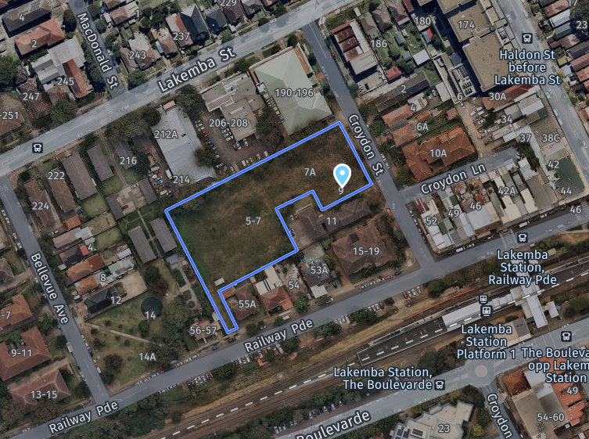
Figure 1 Site Location Plan and surrounding local area (source Nearmap 2021)

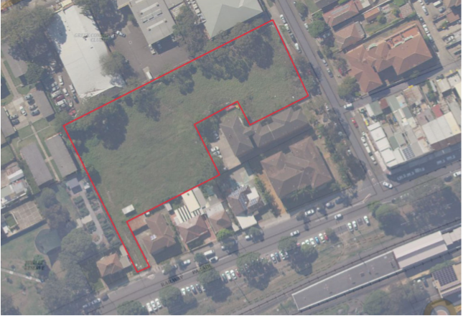
Figure 2 Site outlined in red (source SEE)

PROPOSED DEVELOPMENT

The Development Application proposes:

- Torrens title subdivision to create two parcels of land:
  - A publicly access laneway with access to the development basement, to be dedicated to Council to improve connectivity (approximately 1750sqm)
  - A development lot (approximately 4617sqm)

- Construction of three (3) residential buildings providing a total of 144 residential apartments:

Building A
- Part 5/7 Storeys with a half lower-ground storey
  - 33 x 2 bedroom apartments
  - 2 x 3 bedroom apartments
Building B
- Part 5/7 storey
  - 6 x 1 bedroom apartments
  - 27 x 2 bedroom apartments
  - 2 x 3 bedroom apartments
Building C
- Part 7/10 storey
  - 7 x studio apartments
  - 6 x 1 bedroom apartments
  - 49 x 2 bedrooms apartments
  - 12 x 3 bedrooms apartments
- Roof top communal area (200sqm) along the southern side of the building including a landscaped area and fitness area.
- Strata subdivision of the apartments.
- Communal open space (912sqm primary and 199sqm secondary) provided at ground level and through a rooftop terrace (200sqm Building C).
- A two level basement extending below the three buildings accommodating 163 car parking spaces including 13 accessible spaces as well as waste storage rooms for each building.
- A lower ground level within Building A accommodating storage cages and bicycle along with building services and manager’s office.
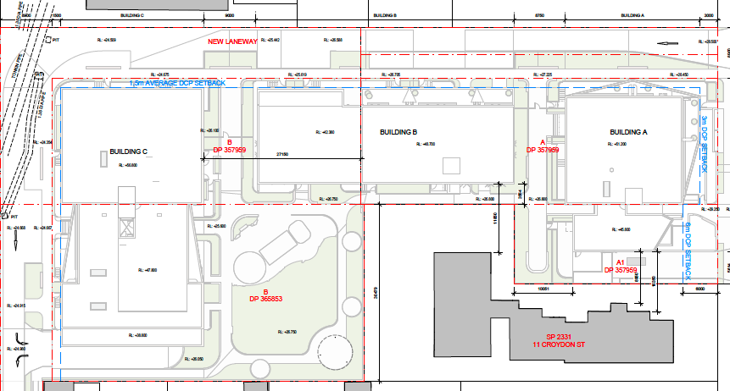
Figure 3 – site plan (source Studio Hollenstein Matthew Pullinger Architect)
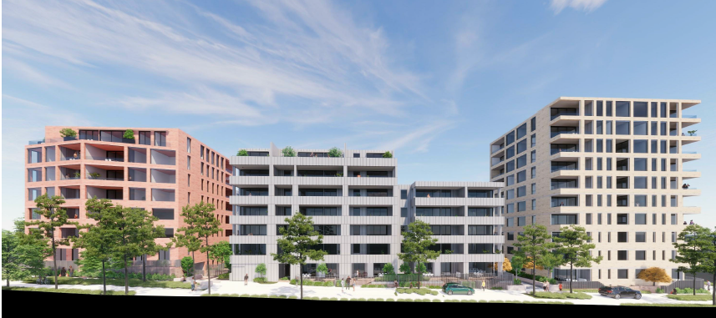
Figure 4 – 3D of site from laneway, northern elevation (source Studio Hollenstein Matthew Pullinger Architect)
Statutory Considerations
When determining this application, the relevant matters listed in Section 4.15 of the Environmental Planning and Assessment Act 1979 must be considered. In this regard, the following environmental planning instruments, development control plans, codes and policies are relevant:
- Water Management Act 2000
- State Environmental Planning Policy (Planning Systems) 2021
- State Environmental Planning Policy (Resilience and Hazards) 2021
- State Environmental Planning Policy 65 – Design Quality of Residential Apartment Development (SEPP 65)
- State Environmental Planning Policy (Transport and Infrastructure) 2021
- State Environmental Planning Policy 2004 (Building Sustainability Index: BASIX)
- State Environmental Planning Policy (Biodiversity and Conservation) 2021
- Canterbury Local Environmental Plan 2012
- Canterbury Development Control Plan 2012
- Canterbury Development Contributions Plan 2013 (Contributions Plan 2013)
- Draft Consolidated Canterbury Bankstown Local Environmental Plan

SECTION 4.15 ASSESSMENT

The proposed development has been assessed pursuant to section 4.15 of the Environmental Planning and Assessment Act, 1979.

Environmental planning instruments [section 4.15(1)(a)(i)]
Water Management Act 2000
A Geotechnical Investigation Report prepared by JK Geotechnics (1 June 2021), Ref: 24633Lrpt-rev1. The report noted that groundwater seepage was encountered in the boreholes during auger drilling. The results of the groundwater monitoring generally show that there is a groundwater gradient from north-east to south-west, with the highest groundwater levels recorded in BH6 and the lowest recorded in BH7.
The report concluded that from a geotechnical perspective, if a tanked basement is adopted, the proposed development will not have an adverse affect on adjoining structures. Notwithstanding the above, the application was referred to Water NSW pursuant to Clause 90(2) of the Water Management Act 2000. WaterNSW provided their general terms of approval on 22 December 2021. These have been incorporated into the recommended conditions of consent.
Considering the above, the application satisfies the requirements of the Water Management Act 2000.
State Environmental Planning Policy (Planning Systems) 2021

According to SEPP (Planning Systems) a regional panel may exercise the consent authority functions of Council for the determination of applications included in Schedule 6 for general development that has a capital investment value of more than $30 million. The proposal has a capital investment value of $43,944,840.00 and therefore falls within this category.

A Panel Briefing was held on 10 June 2021. The Panel noted a number of issues at the briefing, which are provided below

Key Issues Discussed

The Panel discussed the following:

- The development, while compliant in terms of FSR, is large in scale and bulk, with limited building separation, modulation and articulation, and open space for substantial tree planting. To enhance the architectural expression and landscape quality, neighbourhood character and amenity, various non-compliances need to be addressed, notably:
- Building height exceedance of Building C
- ADG issues, specifically
  - Building Separation - inadequate separation at higher levels, and with neighbouring properties
  - Solar Access and Daylight Access,
  - Natural Ventilation,
  - Apartment Size and Layout,
  - Common Circulation Spaces,
  - Storage Areas
  - Acoustic Privacy.
  - Deep soil
- Key DCP requirements that have not been addressed:
- Insufficient car parking,
- Building Depth and Length,
- Street setbacks and wall heights,
- Upper level setbacks,
- Deep soil zones,
- Communal open space,
- View corridors,
- Building exteriors, materiality, articulation, and modulation
- SEPP 55 considerations yet to be demonstrated.
- Cl 4.6 justification is yet to be demonstrated

Subsequent amendments were made to the proposal in November 2021 and May 2022 to address the above issues, which are discussed in detail further in the report.

State Environmental Planning Policy (Resilience and Hazards) 2021 – Chapter 4 Remediation of Land (SEPP 55)
Clause 4.6 of SEPP (Resilience and Hazards) Remediation of Land requires Council to consider whether the land is contaminated prior to granting consent to the carrying out of any development on that land. Should the land be contaminated, we must be satisfied that the land is suitable in a contaminated state for the proposed use. If the land requires remediation to be undertaken to make it suitable for the proposed use, we must be satisfied that the land will be remediated before the land is used for that purpose.
The applicant has submitted a Geotechnical Investigation, and Detailed Site Investigation (Aargus, August 2021). The reports contain recommendations with regard to future excavation, building foundations and contamination management. Council’s Environmental Health Officer has reviewed the documents and is satisfied, subject to the imposition of suitable conditions of consent. Accordingly, the submitted reports demonstrate that the site is suitable for the purpose of the proposed development in accordance with SEPP (Resilience and Hazards).
State Environmental Planning Policy (Transport and Infrastructure) 2021
Ausgrid
The proposed development involves works within 5m of overhead power and requires the installation of a new substation. In accordance with clause 45 of SEPP (Infrastructure), a referral to the electricity supply authority for the area was required. Ausgrid responded advising they had no comments on the proposal. A substation is proposed to the southern side of Building A with access provided. The applicant’s level 3 electrical engineer has confirmed the proposed substation location and design is acceptable against Ausgrid’s requirements.
Sydney Trains
The development is further than 25m horizontally from a train corridor, but was referred to Sydney Trains under Clause 2.99 of the SEPP. Sydney trains advised they raised no objection to the proposed development subject to imposition of appropriate conditions.
State Environmental Planning Policy 2004 – (Building Sustainability Index: BASIX)
In accordance with BASIX SEPP, a BASIX Certificate accompanies this application. The Certificate makes a number of energy/resource commitments relating to water, energy and thermal comfort. The relevant commitments indicated on the BASIX Certificate have been shown on the plans in order to satisfy objectives of the SEPP. The BASIX Certificate requirements have been incorporated into conditions of consent.
State Environmental Planning Policy (Biodiversity and Conservation) 2021 – Chapter 2 Vegetation in non-rural areas
The proposed development seeks approval for the removal of 13 trees. Council’s Landscape Architect has reviewed the application and raised no objection to the removal of the trees, subject to conditions, including requiring replanting with low water requirements, are drought tolerant and reduce lawn areas to minimise lawn use. Native planting should occur where possible.
State Environmental Planning Policy 65 - Design Quality of Residential Apartment Development (SEPP 65)
This policy applies to residential apartment development and is required to be considered when assessing this application. Residential apartment development is defined under SEPP 65 as development for the purpose of a residential flat building, shop top housing or mixed use development with a residential accommodation component. The development must consist of the erection of a new building, the conversion of an existing building or the substantial redevelopment or refurbishment of an existing building. The building must also be at least 3 or more storeys and contain at least 4 or more dwellings. Residential apartment development does not include boarding houses or serviced apartments.
SEPP 65 aims to improve the design quality of residential apartment development across NSW and provides an assessment framework, the Apartment Design Guide (ADG), for assessing ‘good design’. Clause 50(1A) of the Environmental Planning and Assessment Regulation 2000 requires the submission of a design verification statement from a qualified designer (registered architect) at lodgement of the development application that addresses the design quality principles contained in SEPP 65 and demonstrates how the objectives in Parts 3 and 4 of the ADG have been achieved. These principles are discussed as follows:
Principle 1: Context and Neighbourhood Character
The site is located within the R4 zone and is consistent with the objectives of the zone as the development consists of three well-designed residential flat buildings in an accessible area adjoining Lakemba train station. The delivery of a new publicly-accessible laneway dedicated to Council will improve accessibility and connectivity within the surrounding area.
The design ensures that the proposed development is appropriate in terms of scale and bulk. The proposal is compatible with the existing and desired future character of the area, which is going through transition, and will contribute to the quality and identity of the immediate locality.
Principle 2: Built Form and Scale
The development is generally consistent with Council’s height controls and will align with the desired future character of the locality. The design ensures that the proposed development is appropriate in terms of scale and bulk. The proposed development is also generally consistent with Council’s DCP envelope controls, and where variations are proposed, they are justified by demonstrating consistency with the objectives.
The faced design of the proposal has been amended to give greater diversity and character to each building within the proposal. The material palette for each building was developed to reflect the predominant materials of the context – which includes terracotta red brick, silver grey profiled metal cladding and blonde brick. As amended, the range of materials also contributes to the articulation of the building and reducing the overall bulk and mass of the building.
Principle 3: Density
The proposed development complies with the maximum FSR control that applies to the site and achieves a high level of amenity for future residents while also protecting the amenity of existing surrounding residents. Accordingly, the density of the proposed development is considered to be satisfactory and a reasonable response to the desired future context and built form.
Principle 4: Sustainability
A BASIX Certificate has been submitted to Council with this development application, which details the resource, energy and water efficiency measures that will be incorporated into this proposal.
Principle 5: Landscape
The proposal incorporates landscaping at ground level (1,000sqm) as well as well as a communal rooftop area on Building C of approximately 200sqm. Sufficient deep soil area is incorporated into the proposed design, including a contiguous area of approximately 912sqm at ground-floor.
Landscape details have been provided which have been reviewed and generally compliant or exceeding the landscaping controls within the ADG and Council’s DCP provisions. All the proposed apartments have access to private open space, in the form of balconies, and the development provides generous landscaping across the site.
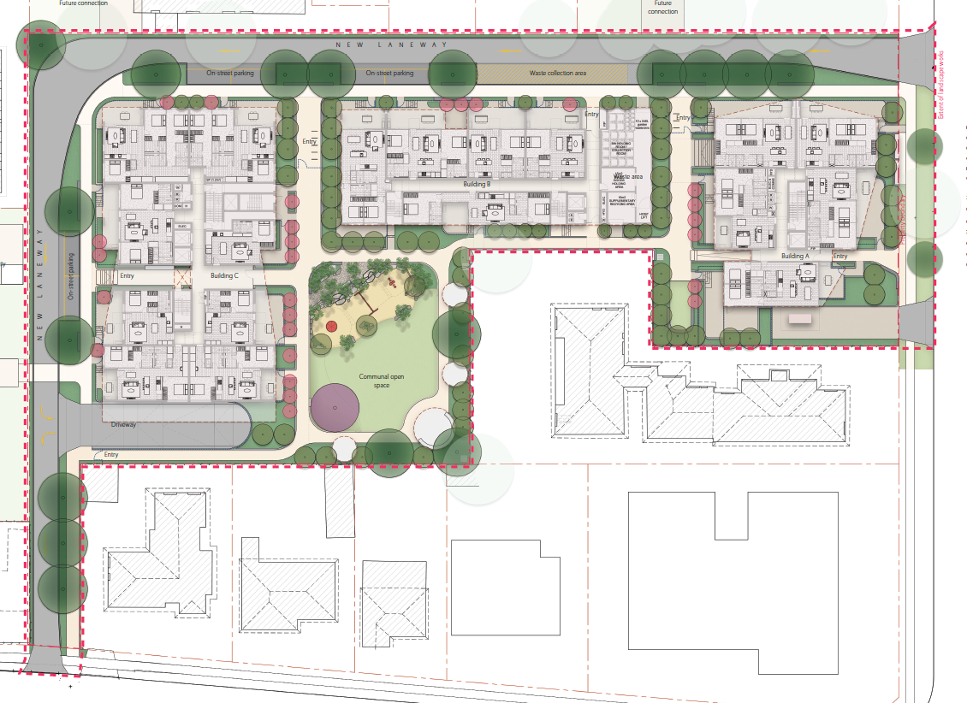
Figure 5 – Ground floor landscaping (source Matthew Pullinger Architect, Studio Hollenstein)
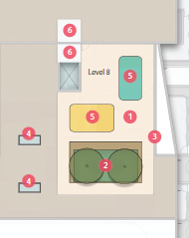
Figure 6 – Roof top landscaping (source Matthew Pullinger Architect, Studio Hollenstein)
Principle 6: Amenity
The proposed development has been designed to maximise solar access. The proposed units will have considerable internal amenity. Their size and room dimensions exceed the minimum standards within the Apartment Design Guide. As such they will provide more than adequate space to meet the needs of future occupants. The proposed development meets the amenity requirements within the ADG including, unit size and layout, storage, solar access, natural and cross ventilation, private open space, and visual and acoustic privacy.
Storage is provided within all units with additional storage within Building A storage and bike parking cages, whilst the outdoor private terraces are of sufficient size to meet the recreational needs of future occupants. Lift access has been provided from the basement throughout the building, thereby providing full accessibility for all residents and visitors.
Principle 7: Safety
The applicant has report demonstrating the proposal’s consistency with the Crime Prevention through Environmental Design (CPTED) principles as outlined in CDCP 2012 in the design of the project. The proposal outlines how the principles are achieved, including:
- The proposal seeks to enhance passive surveillance across the site through the introduction of a new laneway and through site link which will be dedicated to Council increasing activation within the site and providing increased frontage and visual links to Jubilee Reserve.
- The apartments have been designed such that ground floor apartments have private open space which fronts Croydon Street and the new laneway providing a positive street address and along with upper level balconies overlooking the street will provide for passive surveillance enhancing public safety.
- The new laneway provides for clear sight lines from Croydon Street to Jubilee Reserve and with future adjacent development will provide a clear sign line from Railway Parade to Lakemba Street.
- The proposed development clearly defines the public spaces and the communal spaces and private spaces within the apartment complex through use of fencing and landscaping. This has been designed to maintain visual connections between the street and laneway and the communal open space and private open space to maximise opportunities for overlooking and passive surveillance.
- The communal internal and outdoor spaces and lifts within the development will be secure and accessible via access passes / intercom systems. This will be supported by CCTV within key communal spaces. Secure access / intercom systems will also be provided to the basement areas. All windows and doors, including to communal space will be lockable to enable security to be maintained.
- The site has been vacant for some time and its redevelopment will enhance safety through activation of the space and through provision of clearly defined and attractive public and communal spaces.
- The development of the vacant site will ensure ongoing care and management of this space. The new laneway will be developed to a high quality and dedicated to Council for ongoing management. The communal spaces within the apartment have also been designed to encourage a high level of use through high quality landscape and finishes.
Principle 8: Housing Diversity and Social Interaction
The proposed design incorporates various dwelling sizes from studio apartments through to many generous three-bedroom apartments, and includes adaptable and liveable units promoting diversity, affordability and access to housing choice.
Principle 9: Aesthetics
The application is accompanied by a Design Verification Statement and confirms that the development satisfies the general design principles contained within SEPP 65. The proposed use of pattern, texture, form and colour seeks to produce a design aesthetic that reflects the quality of residential accommodation provided. The articulation of the external façades and compliance with the relevant built form standards lessens any perception of bulk, whilst maintaining internal and external amenity. These elements contribute to the desired future character of the locality and enhance the existing surrounding streetscapes.
Apartment Design Guide
Further to the design quality principles discussed above, the proposal has been considered against the various provisions of the Apartment Design Guide in accordance with Clause 28 (2) (c) of SEPP 65.
Section | Design Criteria | Proposed | Complies
Part 3 Siting the Development
3B-Orientation | - Solar access to living rooms, balconies and private open spaces of neighbours should be considered  - Where an adjoining property does not currently receive the required hours of solar access, the proposed building ensures solar access to neighbouring properties is not reduced by more than 20% (CDCP 2012  - C2 Proposed development must retain a minimum of 3 hours of sunlight between 8.00am and 4.00pm on 21 June for existing primary living areas and to 50% of the principal private open space.  - C3 If a neighbouring dwelling currently receives less than 3 hours of sunlight, then the proposed development must not reduce the existing level of solar access to that property –  - If the proposal will significantly reduce the solar access of neighbours, building separation should be increased beyond minimums contained in section 3F Visual privacy and overshadowing should be minimised to the south or downhill by increased upper level setbacks. | - 9 of the 13 apartments at 11 Croydon St currently achieve 2 hours solar access to livingroom windows and balconies.  - A break in the buildings A and B has been introduced to maintain solar access, with 6 units continuing to retain solar access under the scheme, which is a reduction of 20% and should be considered acceptable given the planning controls approved on site.  - The overshadowing analysis clearly shows that the single dwellings at 54 and 57 continue to meet solar access requirements, and the buildings at 54A and 53A are used for non-residential uses, but would also achieve the solar access requirement.  - In addition, the solar analysis undertaken for 55 Railway Parade also demonstrates that the proposal maintains an appropriate level of solar access to all existing dwellings. | Yes
3C Public Domain Interface | - Avoid long, high blank walls and fences  - Direct access from the street to ground floor apartments and windows overlooking the street improve safety and social interaction;  - Key components to consider when designing the interface include entries, private terraces or balconies, fence and walls, changes in level, services location and planting.  - Safety considerations (real or perceived) and consideration of social interaction opportunities when viewed from the public domain.  - Terraces, balconies and courtyard apartments to have direct street level entry where possible;  - Changes in levels between ground floor and terraces to balance passive surveillance and privacy;  - Provide seating at building entries, letter boxes and private courtyards adjacent the street.  - Multiple building entrances to be clearly defined through architectural detailing, changes in materials, plant species and colours;  - Concealment opportunities minimised. | - Blank walls are avoided, as openings are provided along each elevation, which facilitates improved amenity for future occupants.  - Ground apartments facing the laneway and internal communal open space all have access out from these external spaces rather than an internal corridor.  - The building has been designed to incorporate private open space/habitable rooms facing the internal communal areas as well as the adjoining public domains to facilitate passive surveillance.  - Changes in levels between ground floor and terraces are managed to balance passive surveillance and privacy.  - Conditions to be imposed to ensure letterboxes are adjacent to the street, where appropriate.  - Multiple building entrances are clearly defined. | Yes, subject to conditions
3D Communal and Public Open Space | Communal open space has a minimum area equal to 25% of the site. Total site area is 6,367m², requiring a minimum 1,591.75m²)  Min 6m dimension. | The proposal exceeds the ADG requirements, through its provision of the following communal spaces:  - Primary ground-floor communal open space of 912sqm (32.2mx26.3m)  - Secondary ground-floor communal open space of 199sqm (6.6x23.2)  - Rooftop communal space on building C of 217sqm (11.8x18.4) | Complies
3D Communal and Public Open Space | Developments achieve a minimum of 50% direct sunlight to the principal usable part of the communal open space for a minimum of 2 hours between 9 am and 3 pm on 21 June (mid-winter). | - The communal roof area on Building C achieves 50% direct sunlight on the principal usable part between 9am till 12pm, and still receives some additional sunlight till 1pm.  - The primary ground-floor communal open space, does not receive a total of 50%, but does achieve areas of meaningful sunlight across the area between 9am – 2pm. | Complies
3E  Deep Soil Zones | Deep soil zones are to meet the following minimum dimensions:  On some sites it may be possible to provide larger deep soil zones, depending on the site area and context:  • 10% of the site as deep soil on sites with an area of 650m² - 1,500m²  • 15% of the site as deep soil on sites greater than 1,500m²  15% of 4612m² (developable area)– 691.80m² | - The proposal delivers deep soil within the development lot of 362sqm, in dimensions greater than 6m (7.8%). It also delivers deep soil of 420sqm (9.1%) in area where one dimension is less than 6m. This constitutes an overall deep soil calculation of 16.9% of site area being delivered as deep soil.  - Whilst the laneway will be publicly owned, it also delivers significant additional deep soil to the immediate precinct of 340sqm or 19.4% of laneway area, which will assist in water flow and cleaning, stormwater management and generous landscape planting.  - Whilst the site is greater than 1,500sqm, and delivers 782sqm of deep soil – which exceeds the control, some of that deep soil has one dimension less than 6m.  - In addition, the future laneway also provides generous deep soil areas constituting a total of 782sqm or 16.9% of the developable area. | Complies  Complies with objective
  Site Area | Minimum Dimensions | Deep Soil Zone (% of site area)
  Less than 650m² | - | 7%
  650m² - 1,500m² | 3m | 7%
  Greater than 1,500m² | 6m | 7%
  Greater than 1,500m² with significant existing tree cover | 6m | 7%
3F  Visual Privacy | Separation between windows and balconies is provided to ensure visual privacy is achieved. Minimum required separation distances from buildings to the side and rear boundaries are as follows:  Note: An increased 3m building separation is required when the adjoining land a different zone that permits lower density residential. | Building A  - Building A has a setback of 5.6m to the southern boundary, slightly less than the six metre requirement. Its separation to the southern neighbour is 8.95m and 10.35m to the building façade.  - Whilst this does not strictly comply with the numerical controls, the proposal is considered acceptable for the following reasons:  - The variant for the subject DA is only 400mm less than the compliant 6m  - The lower floor units less than 6m from the property boundary have no or limited south facing windows, with all primary living areas oriented to the east and west to managed visual and acoustic privacy. Where windows face south, they are blinkered to ensure privacy  - It is noted that much of the non-compliance comes from the existing development to the south sitting very close to the boundary of the subject site.  Building B  - Is separated from the southern neighbour by 11.85m, which is only 0.5m less than the required 12m.  - No unit is proposed at the ground floor adjacent the neighbour to the south, which is largely replicated up the building with lift and plant services located opposite the building.  - Blinkered windows have been added to Levels 2 to 7 to minimise visual privacy impacts.  Building C  - Due to the new publicly assessable laneway, the proposed development at Building C will be at least 10m from the boundary of any future development, which will then enable  modest building setbacks for future development to comply with the subject provisions. Given the smaller scale developments proposed as part of Council’s controls, building separation will not be difficult to achieve in future.  Building A/B and B/C  - Separation between these buildings are 8.75m and 9.26m respectively and have proposed blinkered windows to manage visual and acoustic privacy within the site. | Broadly complies
  Building Height | Habitable Rooms & Balconies | Non-habitable Rooms
  Up to 12m (4 storeys) | 6m | 3m
  Up to 25m (5-8 storeys) | 9m | 4.5m
  Over 25m (9+ storeys) | 12m | 6m
3J  Bicycle and Car Parking | For development within 800 metres of a railway station the minimum car parking requirement for residents and visitors is the lesser of that set out within the Guide to Traffic Generating Developments or Council requirements as set out in the table below. Otherwise, the CDCP 2012 | - The subject site is located approximately 150m from Lakemba Train Station and the Guide to Traffic Generating Developments was used to determine the car parking rates as it was the lesser requirement.  - Utilising the Subregional Centre RMS rate (agreed to by Council), the proposed development requires 163 spaces, including 13 adaptable rates and a car wash bay. | Complies
3J  Bicycle and Car Parking | The car parking needs for a development must be provided off street. | - The car parking is provided off street and located within two levels of basement. | Complies
3G Pedestrian Access and Entries | Multiples entries should be provided to activate the street edge.  Entry locations relate to the street and subdivision pattern / existing pedestrian network.  Building entries should be clearly distinguishable from private entries.  Building access areas (lift lobbies, stairwells and hallways) should be clearly visible from public domain and communal spaces.  Minimise ground floor and underground level changes along pathways and entries. Steps and ramps integrated into design.  Provide way finding maps for large developments. Electronic access and audio/video intercoms required.  Provide pedestrian links to streets and destinations with clear sight lines. | - Multiple entries are provided, both into the building and along the street edge through individual entries to ground-floor apartments.  - The entry locations are chosen to maximise ease of movement throughout the development and to be clearly distinguishable from private entries.  - Building access areas are visible from the public domain and communal spaces  - Steps and ramps for ground level changes have been minimised and integrated into design.  - Electronic access and audio/video intercoms will be provided.  - Pedestrian links are provided to streets and destinations with clear sight lines. | Complies
Part 4 Designing the Building
4A  Solar and Daylight Access | Living rooms and private open spaces of at least 70% of apartments in a building receive a minimum of 2 hours direct sunlight between 9 am and 3 pm at mid-winter. | - The solar access requirements are met and can be demonstrated in accordance with the analysis undertaken in DA011 | Complies
4A  Solar and Daylight Access | A maximum of 15% of apartments in a building receive no direct sunlight between 9 am and 3 pm at mid-winter |  | Complies
4B  Natural Ventilation | At least 60% of apartments are naturally cross ventilated in the first nine storeys of the building. Apartment at ten storeys or greater are deemed to be cross ventilated only if any enclosure of the balconies at these levels allows adequate natural ventilation and cannot be fully enclosed. | - Amended information submitted by the applicant shows that 60.4% of apartments can achieve cross ventilation, which meets the ADG requirement.  - In addition, Windtech provided a supporting statement confirming the level of cross-ventilation can be achieved. | Complies
4B  Natural Ventilation | Overall depth of a cross-over or cross-through apartment does not exceed 18m, measured glass line to glass line. | - The majority of crossover apartments do not exceed 18m measured glass line to glass line.  - Where these depths are exceeded by units in Buildings A and C, they still achieve the requirement for maximum depth of 8m from face of glass to back of kitchen wall. The remainder of variations occur in part due to generous balconies and numerous corner apartments, and will still achieve appropriate amenity outcomes. | Largely complies
4C  Ceiling Heights | Measured from finished floor level to finished ceiling level, minimum ceiling heights are:  These minimums do not preclude higher ceilings if desired. | The proposal seeks 3.1m floor to floor heights and would therefore be able to achieve the minimum ceiling height of 2.7m | Complies
  Minimum Ceiling Height for Apartment and Mixed Use Buildings
  Habitable rooms | 2.7m
  Non-habitable | 2.4m
  For 2 storey apartments | 2.7m main living area floor  2.4m for second floor, where its area does not exceed 50% of the apartment area
  Attic Space | 1.8m at edge of room with a 30 degree minimum ceiling slope
  If located in mixed use areas | 3.3m for ground & first floor to promote future flexibility of use
4D Apartment Size and Layout | Apartment are required to have the following minimum internal areas:  The minimum internal areas include only one bathroom. Additional bathrooms increase the minimum internal area by 5m² each.  A fourth bedroom and further additional bedrooms increase the minimum internal area by 12m² each. | The required minimum internal areas for the relevant apartment  type have been met with the exception of the following apartments:  Building C  C17-1C (1br of 49sqm) and C18-1D (1br of 47sqm).  These two units are at ground floor and have generous open space onto the future communal area. Whilst small, they are well designed to maximise functionality, and their location ensures they further maximise amenity from the communal areas of the development. These slight unit size variations are therefore considered acceptable. | Generally Complies
  Apartment Type | Minimum Internal Area
  Studio | 35m²
  1 bedroom | 50m²
  2 bedroom | 70m²
  3 bedroom | 90m²
4D Apartment Size and Layout | Every habitable room must have a window in an external wall with a total minimum glass area of not less than 10% of the floor area of the room. Daylight and air may not be borrowed from other rooms. | Complies | Complies
4D Apartment Size and Layout | In open plan layouts (where the living, dining and kitchen are combined) the maximum habitable room depth is 8m from a window. | All units have a maximum habitable room depth of 8m from a window. | Complies
4D Apartment Size and Layout | Master bedrooms have a minimum area of 10m2 and other bedrooms 9m² (excluding wardrobe space). | The required minimum internal  areas for the relevant bedrooms  type have been met. | Complies
4D Apartment Size and Layout | Bedrooms have a minimum dimension of 3m (excluding wardrobe space). | All bedrooms have a minimum dimension of 3m. | Complies
4D Apartment Size and Layout | Living rooms or combined living/dining rooms have a minimum width of:  - 3.6m for studio and 1 bedroom apartments  - 4m for 2 and 3 bedroom apartments | Achieved | Complies
4D Apartment Size and Layout | The width of cross-over or cross-through apartments are at least 4m internally to avoid deep narrow apartment layouts. | No cross-over apartments, however the cross-through apartments have widths greater than 4m and will not result in deep narrow apartments | Complies
4E  Private Open Space and Balconies | All apartments are required to have primary balconies as follows:  The minimum balcony depth to be counted as contributing to the balcony area is 1m. | - All balconies now achieve the minimum requirement of the ADG of 10sqm in area and 2m depth.  - However, the three bedroom apartment facing north (A72-2=3D), which has a generous 29sqm north facing balcony is 2.58m deep at its widest point.  - However, a total area of 12sqm of the balcony has a width of between 1.91-2,58m, which is generally considered acceptable for balcony functionality. | Generally Complies
  Dwelling type | Minimum Area | Minimum Depth
  Studio apartments | 4m² | -
  1 bedroom apartments | 8m² | 2m
  2 bedroom apartments | 10m² | 2m
  3+ bedroom apartments | 12m² | 2.4m
4E  Private Open Space and Balconies | For apartments at ground level or on a podium or similar structure, a private open space is provided instead of a balcony. It must have a minimum area of 15m² and a minimum depth of 3m. | - Four of the 20 GF apartments do not have either the required 15m² and /or 3m depth. All units range from 11sqm of ground-floor space up to 45sqm. For the units that do not achieve the 15sqm area, they are located directly adjacent to the communal open space. | Partially complies
4F  Common Circulation and Spaces | The maximum number of apartments off a circulation core on a single level is eight.  Where design criteria 1 is not  achieved, no more than 12  apartments should be provided  off a circulation core on a single  level. | - Building A and B have less than 8 apartments off a circulation core.  - The following levels will be serviced with more than 8 apartments off a circulation core:  - Building C:  - Levels 2-7 – 9 apartments. Although the apartments exceed 8 units off a circulation core, the ADG allows for up to 12 apartments. The proposal will not exceed 12 units off a single circulation core and the proposal provides two lift cores and would adequately service the development | Generally Complies
4G  Storage | In addition to storage in kitchens, bathrooms and bedrooms, the following storage is provided:  At least 50% of the required storage is to be located within the apartment. | - Applicant has provided plans clearly showing where storage is located in each unit and where the storage cages are located to meet the requires of this provision.  - The updated drawings DA13 (Rev e) clearly show the storage locations and sqm within units and separate storage cages in Building A | Complies
  Dwelling type | Storage size volume
  Studio apartments | 4m³
  1 bedroom apartments | 6m³
  2 bedroom apartments | 8m³
  3+ bedroom apartments | 10m³
4H Acoustic Privacy | Adequate building separation is provided within the development and from neighbouring buildings/adjacent uses  Noisy areas within buildings including building entries and corridors should be located next to or above each other and quieter areas next to or above quieter areas  Rooms with similar noise requirements are grouped together  Noise sources such as garage doors, driveways, service areas, plant rooms, building services, mechanical equipment, active communal open spaces and circulation areas should be located at least 3m away from bedrooms | - Building separation is outlined in the assessment under Part 3F of this table.  - The application was also accompanied by Acoustic Report (Acoustic Logic) which reviews and recommends changes within the development to mitigate impact from noise. These recommendations include:  - Glazed doors and windows  - Entry door treatments  - Attenuation for external roof/ceiling construction  - Measures to manage plant noise.  - Measures to manage driveway operation | Able to comply subject to conditions
4K Apartment Mix | A variety of apartment types is provided | Achieved. The proposal incorporates the following apartment mix  7 x Studio  11 x 1 bedroom  109 x 2 bedrooms  14 x 3 bedrooms | Complies
4Q Universal Design | Developments achieve a benchmark of 20% of the total apartments incorporating the Livable Housing Guideline's silver level universal design features.  20% of 144 = 28.8 rounded up to 29 apartments | The proposal provides 19 adaptable units and 13 silver living apartments a total of 32 | Complies
4S Mixed Use | Mixed use developments positively contribute to the public domain. Design solutions may include:  • development addresses the street  • active frontages are provided  • avoiding blank walls at the ground level  Residential circulation areas should be clearly defined. Design solutions may include:  • residential entries are separated from commercial entries  and directly accessible from the street  • commercial service areas are separated from residential  components  • residential car parking and communal facilities are separated or secured  • security at entries and safe pedestrian routes are provided  • concealment opportunities are avoided  Landscaped communal open space should be provided at and commercial podium or roof levels | The proposal is not a mixed used development | N/A

Canterbury Local Environmental Plan 2012

This site is zoned R4 High Density Residential under CLEP 2012. The controls applicable to this application are discussed below.

Clause 1.2 Aims of Plan

The proposed development is consistent with the relevant aims of the CLEP 2012.

Clause 2.3 Zone objectives and Land Use Table

Clause 2.3(2) of CLEP 2012 outline that the consent authority must have regard to the objectives for development in a zone when determining a development application in respect of land within the zone.

The objectives of the R4 High Density Residential Zone are as follows:

- To provide for the housing needs of the community within a high density residential environment.
- To provide a variety of housing types within a high density residential environment.
- To enable other land uses that provide facilities or services to meet the day to day needs of residents.

The proposed development meets the objectives of the R4 zone as it provides for residential housing within a residential flat building. The design comprises a mix of residential types through incorporating studio, one, two and three bedroom apartments to contribute to the needs of the community.

Provision/ Standard | Requirement | Proposal | Complies
Part 2 Permitted or Prohibited Development
2.1-2.3 Zoning | R4 High Density Residential | Construction of three residential flat buildings ranging from five to 10 storeys with basement level car parking and open space areas and a new roadway to be dedicated to Council. Torrens title subdivision to create separate parcels for the laneway and the development site, and strata subdivision of the apartments. | Complies
2.7 Demolition requires development consent | The demolition of a building or work may be carried out only with development consent. | The subject sites are vacant with some clearing of vegetation. | N/A
Part 4 Principal Development Standards
4.3 Height of Buildings | 18m, 24m, 33m | Building A – 24m  Building B – 18m-24m  Building C – 24m-33m | Complies
4.4 Floor Space Ratio | 2:1 | 1.9:1 | Complies
5.6 Architectural roof features | (2) Development that includes an architectural roof feature that exceeds, or causes a building to exceed, the height limits set by clause 4.3 may be carried out, but only with development consent. | No architectural roof feature proposed | N/A
Part 5 Miscellaneous provisions
5.10(4) Effect of proposed development on heritage significance | The consent authority must, before granting consent under this clause in respect of a heritage item or heritage conservation area, consider the effect of the proposed development on the heritage significance of the item or area concerned. This subclause applies regardless of whether a heritage management document is prepared under subclause (5) or a heritage conservation management plan is submitted under subclause (6). | The subject site is not a heritage item nor within a heritage conservation area | N/A
5.10(5) Heritage Assessment | The consent authority may, before granting consent to any development—  - on land on which a heritage item is located, or  - on land that is within a heritage conservation area, or  - on land that is within the vicinity of land referred to in paragraph (a) or (b),  require a heritage management document to be prepared that assesses the extent to which the carrying out of the proposed development would affect the heritage significance of the heritage item or heritage conservation area concerned. | Council’s hertiage advisor has reviewed the application as the subject site is located within the vicinity of a heritage item identified as Lakemba Railway Station Group. Heritage comments:  “the proposal, is not likely to affect the signficance of the station and the associated significant built fabric, nor impact on its location, placement and prominence within the streetscape.  Having regard to the comments above, the proposal is considered acceptable from a heritage point of view”.  The amended plans have been reviewed and the original position of Council’s heritage advisor still remains - No objection to the proposal. | Complies
Part 6 Local Provisions
6.1 Acid Sulfate Soils | Development consent must not be granted under this clause for the carrying out of works unless an acid sulfate soils management plan has been prepared for the proposed works in accordance with the Acid Sulfate Soils Manual and has been provided to the consent authority. | No affectations | N/A
6.2 Earthworks | Before granting consent to development including earthworks, the following must be considered:  - drainage patterns and soil stability  (b) the likely future use or redevelopment of the land,  (c) quality of the fill or the soil to be excavated, or both,  (d) effect of development on existing and likely amenity of adjoining properties,  (e) the source of any fill material and the destination of any excavated material,  (f) the likelihood of disturbing relics,  (g) the potential for adverse impacts on, any waterway, drinking water catchment or environmentally sensitive area,  (h) appropriate measures proposed to avoid, minimise or mitigate the impacts of the development. | A Detailed Site Investigation prepared by Aargus dated 26 August 2021 was submitted to Council and reviewed by Council’s Environmental health Officer who raised no objections, subject to conditions.  An updated geotechnical report prepared by JKGeotechnics dated 1 June 2021 was received and referred to WaterNSW who provided conditions. | Complies  Complies
6.3 Flood Planning | This clause applies to land at or below the flood planning level.  Development consent must not be granted to development on land to which this clause applies unless the consent authority is satisfied that the development:  (a) is compatible with the flood hazard of the land, and  (b) will not significantly adversely affect flood behaviour resulting in detrimental increases in the potential flood affectation of other development or properties, and  (c) incorporates appropriate measures to manage risk to life from flood, and  (d) will not significantly adversely affect the environment or cause avoidable erosion, siltation, destruction of riparian vegetation or a reduction in the stability of river banks or watercourses, and  (e) is not likely to result in unsustainable social and economic costs to the community as a consequence of flooding. | Council’s development engineers reviewed a revised Flood and Stormwater Report prepared by the applicant in July 2022. Council’s engineer advised that the report demonstrates the design is satisfactory to manage and mitigate risks from flooding on the subject site and surroundings, including sensitivity analysis of buildings, additional storm events, flood hazard mitigation, and impacts on neighbouring properties without freeboard. Subject to imposition of conditions recommended in this report, the proposal complies with the requirements of this Clause.  One of the requirements of the Flood report’s recommendation is to remove the fence between the subject site and Council’s Jubilee Park site. However, in order to balance the flood requirements of the site, whilst also managing safety and privacy matters, a condition is recommended that this fence be replaced with appropriate planting for screening. | Able to comply subject to conditions
6.4 Stormwater Management | Consent must not be granted unless:  - Water permeable surfaces are maximized having regard to soil characteristics affecting on-site stormwater infiltration.  - Includes on-site detention if practical as an alternative means of water supply.  (c) Avoids significant impacts of run-off on adjoining land or the environment or minimises and mitigates impacts. | Council’s development engineer has advised that the stormwater runoff from within the development site shall be collected and controlled by means of an on-site stormwater detention system, in accordance with Council's Canterbury Development Control Plan 2012 Part B5. The developer shall engage a suitably qualified engineer to prepare a final stormwater drainage and on-site detention system plan to be generally in accordance with the concept plan and in accordance with the requirements contained in Council's Canterbury Development Control Plan 2012 Part B5. The Engineer shall certify that the design and plans comply with Council's Canterbury Development Control Plan 2012 Part B5 and the relevant Australian Standards. | Able to comply subject to conditions
6.6 Essential Services | Essential services must be available or adequate arrangements have been made to make them available, including:  - the supply of water;  - the supply of electricity (substation);  - the disposal and - management of sewage;  - stormwater drainage or on-site conservation;  - suitable vehicular access. | A substation is proposed, however is not integrated into the building as required by the DCP.  The applicant has provided additional detail from a specialist Level 3 electrical engineer demonstrating that the proposed substation is acceptable for Ausgrid’s requirements. Ausgrid has made no objection to the proposed substation.  The proposed substation location is considered acceptable as it is located in an unobtrusive, but accessible location, and causes minimal visual disturbance to the development. Given that Ausgrid raises no objection to the substation location, the proposal is considered to be consistent with the requirements of the LEP Clause. | Acceptable solution
Proposed Environmental Planning Instruments [section 4.15(1)(a)(ii)]
The draft Canterbury Bankstown Consolidated LEP does not propose to alter the land use zone, land use permissibility, FSR or Height of Building development standard currently applying to the land.
Having regard to the intended land use and built form of this application no relevant changes are proposed that would impact upon the assessment of the application.
Draft Clause 6.14 Design Quality is proposed to apply to residential flat building developments. Clause 6.14 as drafted and if in force would require a consent authority to have regard to a range of design quality indicators.
In considering the draft Clause 6.14 provisions the consent authority could be satisfied that the proposal:
- Will contribute positively to the Lakemba Local Centre streetscape, with design and street interface consistent with the applicable DCP provisions;
- Will contribute positively to the public domain through providing a publicly accessible laneway that will improve connectivity and access through the precinct, and deliver improved pedestrian amenity conditions;
- Will comprise materials that are durable, high quality and of low maintenance;
- Is of high architectural quality from a well-regarded architectural firm;
- Has sought to maximise solar access, ventilation and acoustic privacy;
- Includes room layouts that are functional and fit for purpose;
- Incorporates appropriate waste management facilities to cater for the proposed use; and
- Integrates landscaping into the design at ground level and within upper levels of the building.
The draft DCP proposes no changes to the provisions currently applying under the Canterbury DCP, other than car parking. As such no further assessment of the Draft DCP is necessary.
Development control plans [section 4.15(1)(a)(iii)]
The following table provides a summary of the development application against the controls contained in relevant sections of the Canterbury Development Control Plan 2012.
Canterbury Development Control Plan 2012 (CDCP 2012)
The proposed development has been compared to the requirements of CDCP 2012 as follows:
Part B1 – Transport and Parking
Car parking:
As per Part 3J Bicycle and car parking of the ADG - Development within 800 metres of a railway station, the minimum car parking requirement within the Guide to Traffic Generating Developments was used in assessing the rates as it is lesser rates when compared with the CDCP 2012. The site is located 160m from Lakemba train station, and is agreed that the subregional centre RMS rates apply to the site, not the Metropolitan Regional (CBD) Centre rate. This results in a requirement for 163 car spaces, including 13 adaptable spaces and one car wash bay, which the development is providing. The car parking requirements of the ADG can be summarised as follows.
19 x 0.6 = 12 (includes studio apartments)
109 x 0.9 = 99
16 x 1.4 = 23
Visitor spaces required 144/5 = 29
Total = 163 plus a car wash bay
Accessible spaces required 144/10- 14 units. 14 accessible spaces required, 16 accessible spaces provided -15 residential spaces and 1 visitor space, which meets the requirements of the RMS traffic generating development guide.
Part B1.3.1 of the CDCP 2012:
Given that the parking spaces are governed by the RMS Guide to Traffic Generating Development, the DCP rates are not applicable in this situation.
Bicycle spaces
Required: Residents: Minimum 1 space per 5 dwellings (144/5 = 28.8 rounded up to 29)
Required Visitors: Minimum 1 space per 10 dwellings (144/10 = 14.4 (14 rounded down))
Total bicycle spaces required: 43
Total bicycle spaces provided: 30 resident bicycle spaces shown on Basement 1 drawing.
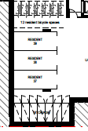
Figure 5 – Bike parking B1 (source Matthew Pullinger Architect, Studio Hollenstein)
16 spaces provided for visitors between buildings A and B and B and C facing the laneway. This constitutes a total of 46 bicycle spaces.
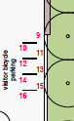
Figure 6 – Visitor bike parking ground floor (total 16 spaces) (source Matthew Pullinger Architect, Studio Hollenstein)
Part B2 – Landscaping and Part B3 – Tree Preservation
The application was supported by an arborist report outlining 13 trees to be removed from the site. These will be replaced with a significant planting schedule of shrubs and mature canopy trees in accordance with the detailed landscape plans.
The Landscape Plan includes a mixture of hardy, low maintenance native and exotic species, which will be maintained by the building owner and are regularly used for residential garden design. The Landscape Design is accompanied by a ‘Maintenance Requirements and Management Plan’.
Part B4 – Accessible and Adaptable Design
The access report prepared by Vista Access Architects ref number: 19146 was submitted as part of the DA. The report concludes that the design generally complies with the relevant standards. Where the design includes some non-compliances, these matters can be resolved through minor design changes or BCA Performance Solutions at the relevant Construction Certificate stage. On this basis, the design is considered acceptable from an accessible and adaptable design perspective.
Part B5 – Stormwater and Flood Management
The application was referred to Council’s Development Engineer who raised who raised a number of concerns with the current design, this is discussed in detail under the heading of “Referrals”. Although this item will be discussed in detail in further sections, there is an acceptable solution for stormwater and flood management for the site when considered against both local and state requirements.
Part B7 – Crime Prevention and Safety
The application was referred to Council’s Community Safety Officer who requested for information to forward onto NSW Police and Crime Prevention Officers for comment.
The applicant provided an analysis of the proposal against the principles in May 2022, which is detailed below.
Standard | Requirement | Proposal | Complies
Crime Prevention through Environmental Design | Avoid blind corners | The proposed new laneway will provide for clear sight lines from Croydon Street to Jubilee reserve, with future adjacent development to provide a clear sight line from Railway Parade to Lakemba.  Within the development, buildings are designed with chamfers where appropriate to avoid blind corners and with wide footpaths. | Complies
Crime Prevention through Environmental Design | Provide natural surveillance for communal and public areas. | All communal and public space has units overlooking them, with ground floor apartments also having individual entries out to these spaces. | Complies
Crime Prevention through Environmental Design | Provide clearly visible entries. | All entries are clearly visible | Complies
Crime Prevention through Environmental Design | Design the fence to maximise natural surveillance from the street to the building. | Fencing has been carefully designed with solid bases and permeable materials above as well as landscaping to combine privacy with natural surveillance from the street to the building. | Complies
Crime Prevention through Environmental Design | Avoid landscaping that obstructs natural surveillance. | The landscaping proposed has been designed to maintain visual connections between the street and laneway and the communal and private open space to maximise opportunities for overlooking and passive surveillance. | Complies
Crime Prevention through Environmental Design | Ensure buildings are clearly identified by street numbers. | Buildings will be clearly identified by street numbers. | Complies
Crime Prevention through Environmental Design | Use materials that reduce the opportunity for vandalism. | The materials chosen are high quality, resilience materials that will minimise vandalism risk. | Complies
Crime Prevention through Environmental Design | Provide an appropriate level of security for individual dwellings and communal areas through use of intercoms, self closing doors and signage. | Entrance point to lobbies are visible from the public street, but provide safety through CCTV, wayfinding signage. All windows and doors, including communal space, will be lockable to enable security to be maintained. | Complies

Part B9 - Waste
The application was referred to Council’s Project Officer – Resource Recovery who raised no objection with the current design, subject to conditions of consent.
C4 - Residential Flat Buildings
An assessment of the proposal against the relevant provisions contained in Part C4 of CDCP 2012 is provided below:
Standard | Requirement | Proposal | Complies
C4.2.1.1 - Frontage | 4+ storey building: Min 30m frontage | 44.355m (frontage to Croydon Street) | Complies
C4.2.1.2 - Isolated Sites | Neighbouring properties are not to be isolated so that the property will be unable to reasonably accommodate coordinated development. | The proposed development will not isolate adjoining properties. | Complies
C4.2.1.2 - Isolated Sites | Undertake negotiations with neighbouring owners to seek amalgamation and enable coordinated redevelopment. | Not applicable as the site does not isolate adjoining properties. | N/A
C4.2.1.2 - Isolated Sites | If adjoining owners do not agree on terms of amalgamation, provide evidence of reasonable offers and demonstrate that the isolated site is capable of reasonable redevelopment. |  | N/A
C4.2.1.3 - Open space and balconies | Section 6A of SEPP 65 states that a DCP cannot be inconsistent with the provisions of the ADG made under that SEPP in relation to balconies and development to which the SEPP relates. An assessment against the minimum balcony provisions within the ADG has been undertaken earlier within this report.  Furthermore, an assessment against the communal open space requirements specified within Part F10 of the CDCP 2012 is also undertaken later in this report.
C4.2.1.4 – Layout and Orientation | Orientate development to maximise solar access and natural lighting. | The development has been designed to face north to maximise solar access, while also allowing east and west facing buildings to obtain morning or afternoon sun. | Complies
C4.2.1.4 – Layout and Orientation | Site the development to avoid casting shadows onto neighbouring dwelling’s primary living area, private open space and solar cells. | As discussed earlier in this report, the development has been designed to minimise loss of solar access to surrounding properties. | Complies
C4.2.1.4 – Layout and Orientation | Site new development and private open space to avoid existing shadows cast from nearby dwellings. | The development has been designed to maximise solar access to private open space within the existing development constraints/ | Complies
C4.2.1.4 – Layout and Orientation | The development is consistent with the requirements for cross-ventilation under the Apartment Design Guide.
C4.2.2.2 - Height | Basement that projects greater than 1m above ground level comprises a storey | Noted | Parts of building A and C project over 1m.  - Building A projects 1.5m above ground for part of its northern frontage to the laneway.  - Building C project 1.55m above ground for part of its western frontage to the laneway.
C4.2.2.3 - Setbacks | Development, including basement and sub-floor areas fronting a major road must have minimum 9m front setback. | The site does not front a major road | N/A
C4.2.2.3 - Setbacks | Side: Min 4m | Building A’s side setback is 3m to Croydon Street, with Building C’s site setback being more than 8m due to the future laneway. Internal side setbacks between buildings within the development are all more than 4m | Partially complies
C4.2.2.3 - Setbacks | Rear: Min 6m | Building C has a rear setback of more than 8m. Building B as a rear setback of approximately 4m at its closest boundary. Building A has a rear setback of 5.65m | Partially complies
C4.2.2.3 - Setbacks | Deep Soil – Setbacks:  Front and Rear: Min 5m  Side: Min 2m | Assessed under Part F10 of CDCP 2012 | N/A
C4.2.2.4 - Building Depth and C4.2.2.5 - Separation | Section 6A of SEPP 65 states that a DCP cannot be inconsistent with the provisions of the ADG made under that SEPP in relation to balconies and development to which the SEPP relates. An assessment against the minimum building depth and separation provisions within the ADG has been undertaken earlier within this report.
C4.2.2.6 - Floor to Ceiling | Section 6A of SEPP 65 states that a DCP cannot be inconsistent with the provisions of the ADG made under that SEPP in relation to balconies and development to which the SEPP relates. An assessment against the minimum floor to ceiling provisions within the ADG has been undertaken earlier within this report.
Part C4.2.3 – Building Design
Contemporary Built Form | New building forms and design features shall not mimic traditional features. | The development uses a combination of traditional (terracotta bricks) and contemporary (profiled grey metal cladding) that don’t minimise traditional features | Complies
Contemporary Built Form | Access to upper storeys must not be via external stairs. | No upper storeys can only be reached by external stairs | Complies
Contemporary Built Form | All dwellings must contain one kitchen and laundry. | All dwellings contain a kitchen and a laundry | Complies
Building Entries | Entries to residential buildings must be clearly identifiable. | Building Entries are visible and clearly identifiable | Complies
Building Entries | A minimum of one habitable room per dwelling must be oriented towards the streets. | The development provides at least one habitable room per dwelling oriented towards the street and laneway. | Complies
Building Entries | Ground level private terraces located within the front setback must be setback at least 1m from the street boundary to accommodate a landscape strip which should remain in communal ownership. | All ground level private terraces are set back a combination between 0.5m and 2m to enable a landscape strip, which will remain in communal ownership | Generally complies
Façade Design | Façade design should reflect the orientation of the site using elements such as sun shading devises etc. | The development includes appropriate sun shading devices throughout the building façade. | Complies
Façade Design | Articulating Façade Panels:  Street Elevations: 6m to 8m  Side Elevations: 10m to 15m | The street elevations are appropriately articulated every 6-8m as a consequence of the openings to the building from windows and balconies.  Given the free standing nature of the buildings, the control related to side elevations is not applicable. | Complies
Façade Design | Avoid long flat walls along street frontages – stagger the wall alignment with a step. | The part of the building facing Croydon St (A) incorporates building breaks for balconies and windows and an irregular building envelope and building setbacks. | Complies
Façade Design | Incorporate contrasting elements in the façade. | The facades of each building are made of different primary materials, with contrasting elements utilised for different parts of the façade of each building. | Complies
Façade Design | Layer and step facades in order to avoid buildings forms that are bland, bulky or over scaled. | The facade for each is designed with a gradient of opening, being smaller at street level to provide privacy. This approach also creates architectural roof features at the top of the facades that sit within the upper level setbacks. | Complies
Windows | Windows must be rectangular. | Windows are rectangular | Complies
Windows | Windows and openings shall be appropriately located and shaded to reduce summer heat load and maximum winter sun. | Windows and openings have been appropriately located and shaded to reduce summer heat load and maximise winter sun | Complies
Roof Pitch | Max 10 degrees. | Roof areas do not exceed 10 degrees | Complies
C4.2.3.3 - Dwelling Layout and Dwelling Mix | Section 6A of SEPP 65 states that a DCP cannot be inconsistent with the provisions of the ADG made under that SEPP in relation to balconies and development to which the SEPP relates. An assessment against the minimum dwelling layout provisions within the ADG has been undertaken earlier within this report.
C4.2.3.3 - Dwelling Layout and Dwelling Mix | Min 10% of apartments to be adaptable or accessible.  10% of 144 = 14.4 (14) | 19 apartments nominated as adaptable | Yes
C4.2.4.1 - Solar Access and Overshadowing | Section 6A of SEPP 65 states that a DCP cannot be inconsistent with the provisions of the ADG made under that SEPP in relation to balconies and development to which the SEPP relates. An assessment against the solar access provisions within the ADG has been undertaken earlier within this report.
Solar Access and Overshadowing – Adjoining Development | Section 6A of SEPP 65 states that a DCP cannot be inconsistent with the provisions of the ADG made under that SEPP in relation to balconies and development to which the SEPP relates. An assessment against the solar access provisions within the ADG has been undertaken earlier within this report.
C4.2.4.2 – Acoustic Privacy | Address all requirements in ‘Development Near Rail Corridors and Busy Roads (Interim Guideline’) which has been published by the NSW Department of Planning. | Acoustic privacy has been assessed against the requirements of SEPP (Transport and Infrastructure) 2021 earlier within this report. | N/A
C4.2.5.1 - Fences | Front fences within the front boundary setback are to be no higher than 1.2m | Condition | Complies subject to conditions
C4.2.5.2 - Building services | Integrate systems, services and utility areas within the design of the whole development. | Systems, services and utility areas have been integrated within the development as appropriate. | Complies subject to conditions

Part F Specific Land Uses and Specific Sites

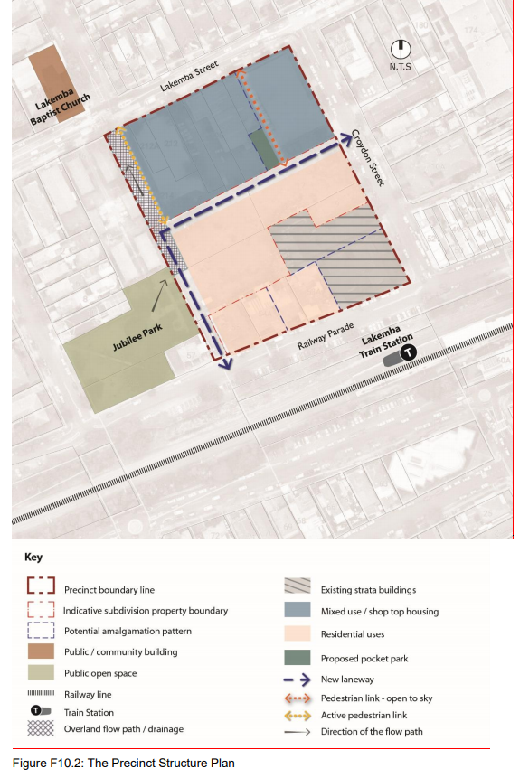
Figure 7 – Site Specific Precinct Structure Plan (Canterbury DCP 2012 Part F)
Standard | Requirements | Proposal | Compliance
10.5 Building Envelopes
F10.5.1 – Building Depth | C1 The maximum overall building depth for residential uses is 18m glass line to glass line or 22m balcony edge to balcony edge. | Building A – 22.8m glass line to glass line 23.2m balcony to balcony  Building B –13.4m glass line to glass line 18.3m -19.5m balcony to balcony  Building C – 18.3m glass line to glass line  24.6m balcony to balcony | No  Yes  No
F10.5.2 – Building Length | C1 The maximum building length is to be 40m with articulation provided through indentations every 10-15m. The proportions of indentations should comply with ADG objective (4B-2) where width to depth ratio should be a minimum of 2:1. | Building A – 29.1m  Building B –26.3m-44.3m - now includes void.  Building C – 20.3m, 42m and-44.8m | Yes  No  No
F10.5.3 – Building Height | C1 The maximum height allowable under the LEP is intended to accommodate all built form including plant, lift and stair access and rooftop communal open space and structures.  C2 The floor to ceiling height of retail/commercial floors is to be a minimum of 3.3m with floor to floor height of minimum 3.7m.  C3 The floor to ceiling height of all residential floors is to be a minimum of 2.7m with floor to floor height of minimum 3.1m. | All buildings comply with maximum permitted height including plant.  N/A  3.1m floor to floor height proposed for all buildings, the development is capable of achieving 2.7m ceiling heights | Yes  N/A  Yes
F10.5.4 – Building Density | C1 The maximum floor space ratio shall comply with the Canterbury Local Environment Plan 2012 Clause 4.4.  C2 The maximum floor space ratio may not be achievable if adverse visual, acoustic or privacy amenity or overshadowing impacts occur to adjacent dwellings, the open space or streetscape in the area. | The development complies with the maximum FSR control of 2:1 | Yes
F10.5.5 Street Setbacks and Street wall heights | C1 The minimum ground level setbacks are to be in accordance with Table F10.2 setbacks and upper level setbacks.  C2 Buildings with commercial and retail uses on the ground floor level may build to the boundary line with nil setbacks to both Lakemba and Croydon Streets.  C3 Residential ground floor uses should accommodate front terrace areas and landscape gardens and provide reasonable amenity.  C4 The street setback area is to be free from any projections or encroachments from any part of new buildings where possible.  C5 Street wall heights shall be relative to the building height in storeys as per table F10.1.  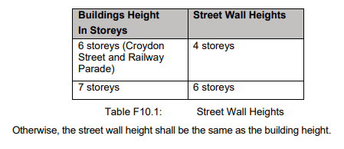 | Refer to assessment below  N/A  Front terrace areas proposed on ground level  The street setback area is largely within the setback zone, with exception of part of a single terrace.  Building A  6 storey (facing Croydon Street) requires a 4 storey street-wall height. Proposal seeks 5.  7 storey component facing Croydon Street requires a 6 storey wall height. Proposal seeks 6, level 7 is setback a further 3m  Building B  7 Storey building (facing lane) - 6 storey street-wall height with 7 storey wall height setback 3m and balcony with no cover encroaching  Building C  7 storey building (facing Jubilee Reserve-requires a 6 storey street-wall height. Proposal seeks 7 storey wall height, with 7 storey setback 3m and part of 7th storey encroaching within the 3m.  Taller corner element of building not subject to a different street-wall height control. | N/A  Yes  Acceptable variation.  No  Yes  Yes  Partial
F10.5.6 – Upper Level setbacks | C1 The minimum upper levels setbacks are to be 3m as per table F10.2 Setbacks and Upper Levels Setbacks.  C2 Upper level setbacks must be free of any projections or encroachments from any part of the building.  C3 The setback area is to be used for private open space where appropriate. The edge is to be created by landscaped planters.  C4 All plant rooms and lift overruns are to be positioned to minimise their visibility. The preference is for all plant to be located within the building envelope or basements rather than the roof. | Building A  Level 7 upper level is setback 3m  Building B  7 storey upper level wall setback 3m and balcony with no cover encroaching  Building C  7-storey upper level has minor projection into 3m setback of a bedroom  All top level balconies show planting.  Achieved. Lift overruns have been setback | Yes  Yes  Yes  No  Yes  Yes
F10.5.7 – Setbacks and upper levels setbacks to the overland flow path -B2 Zone | C1 Setbacks to the overland flow path edge for developments facing the north-western boundary of the precinct should be consistent with the objectives and controls shown in section F10.10: Overland Flow Path of this DCP.  C2 A 6m setback from the overland flow path edge is required to the ground floor level to allow for the provision of an elevated walkway with adequate public interface in line with figures F10.7 and F10.8.  C3 A 3m setback from the overland flow path edge is required for all floors above ground floor level to allow for adequate solar access to the elevated walkway.  C4 An additional 3m setback from the building edge is to be provided above the street wall height as per table F10.1: Street Wall Heights.  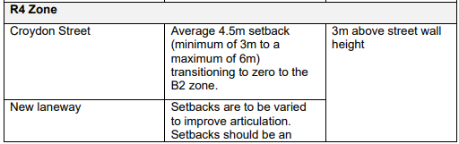  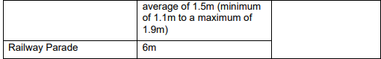  Table F10.2: Setbacks and Upper Levels Setbacks | N/A for B2 zone  N/A for B2 zone  N/A for B2 zone | Refer above. Proposal largely complies with this requirement.
10.5.8 Separation | C1 Provide separation distances between building forms in accordance with the ADG recommendations for building separation.  C2 Deep soil zones shall be provided within the separation distances between the Residential Flat Buildings within R4 zone.  C3 When it is not possible to achieve deep soil requirements as suggested by the ADG objectives, possible alternative forms of planting can be provided on top of podium/structures. | Refer to ADG assessment.  The deep soil zones are around the building due to basement location  Significant planting is provided on top of podiums/structures. | Partial  Yes
10.6 Streetscape
10.6.2 Street Activation - B2 Zone | C1 Active street frontages shall be provided within the B2 zone along Lakemba Street, the new laneway and along the overland flow path.  C2 New developments within the B2 zone should create a “fine grain” retail/commercial response with narrow frontage shops, level/direct pedestrian entries at the footpath level and display areas to promote window shopping as shown in figures at F10.3. | Not applicable to subject application | N/A
10.6.3 Streetscape Character – B2 Zone | C1 Proposals shall demonstrate how new developments will respond to and reinforce both the existing and the desired future streetscape.  C2 New developments along any street or laneway should complement the required street wall heights and setbacks.  C3 All mixed-use developments should provide a human scale and relate to the composition and character of existing buildings at street levels even where taller building forms are provided. | Not applicable to subject application | N/A
10.6.4 Awning Locations | C1 Awnings are to be provided within the B2 zone along Lakemba Street, Croydon Street and the new links/laneway where retail or commercial uses are provided.  C2 Awnings shall define building entries.  C3 Awning design, height and materials are to be generally in accordance with Council standards.  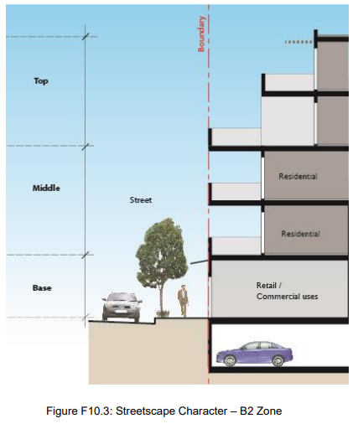 | Not applicable to subject application | N/A
10.6.5 Streetscape Character – R4 Zone | C1 Residential character along Railway Parade and Croydon Street shall be reinforced. Street setbacks with high-quality landscaping are to be provided along these streets.  C2 North facing landscaped open spaces should be provided between the proposed buildings.  C3 All apartments facing the public domain at ground level in the R4 Zone are to have a direct street access.  C4 A terrace area with a depth (minimum 1.1m to a maximum 1.9m) consistent with the setback (Table F10.2) of new laneway with landscape and deep soil beds is to be provided within the front setback area.  C5 A level difference is encouraged between the ground level of the apartment and their terrace and the street.  C6 All substations are to be incorporated into the building form.  C7 Fire stairs are to be provided within the building form and are not to be located in front or side setbacks.  C8 Driveways are to be located within the building form and are not to be located in the side setbacks or building separation areas.  C9 No bin enclosure is to be provided in the front or side setback. | High quality materials, setbacks and landscaping is provided.  North facing landscaping provided.  All apartments at ground level have direct access to the street  The terrace areas have a depth greater that the specified setbacks.  A level difference is proposed  Substation is not incorporated into the built form  Fire stars are not located in the front and side setbacks  Entry into basement should be incorporated into built form. Currently in separation area/ setback.  Bin areas are within the building | Yes  Yes  Yes  Yes  Yes  No. Refer to LEP discussion  Yes  Yes  Yes
10.7 Landscaping
10.7.2 Deep Soil Zones | C1 Deep soil areas should be provided along Croydon Street, Railway Parade and the new links/laneway.  C2 Street trees with high canopies and a mature height of min 5m are to be provided along the length of the new links/laneway to frame views.  C3 Basements are to be contained within the building footprint.  C4 High-quality landscape and canopy trees shall be provided within deep soil area and within street setbacks.  C5 Street trees in accordance with Council’s street tree policy/ public domain plan are to be provided to Lakemba Street, Railway Parade, Croydon Street and the new laneway. | Deep soil is provided outside the basement footprint. Soil depth and type for planting over structures is now shown in the Landscape Drawings. This shows a minimum soil depth of 900mm. The development achieves 362sqm / 7.8% of the developable site area (4,611sqm) as deep soil with a dimension of greater than 6m in width achieving the ADG deep soil criteria. This increases to 739sqm (16%) when taking into consideration deep soil less than 6m width. | Acceptable Solution
10.7.3 Communal Open Space | C6 Communal open spaces are to be provided either in the rear setbacks or the wider open space areas.  C7 An area of central communal open space with minimum dimensions of 28m × 28m comprising a minimum of 900m2 of contiguous communal open space is to be provided in the R4 zone. | 2 CoS are provided.  Ground level COS is located to south of Building B in a wider open space. | Yes  Acceptable Solution. Refer to Landscape Discussion
10.7.4 View Corridors | C1 The built form shall not obscure the view corridors along the new links.  C2 The landscape within view corridors should frame views to public open spaces and should not block eye line level views. | Building separations are adequate to protect view corridors along the new link. | Yes
10.8. Pedestrian and Vehicular Links / Access
10.8.2. New Vehicular and Pedestrian Links / Access | C1 The street reserve width of the new laneway connecting Railway Parade and Croydon Street is to be a minimum of 8.9m including a 6.5m carriageway with a kerb of 1.2m and a verge of 0.6m on one side and a verge of 0.6m on the other side as shown in figure F10.5: Typical New Laneway.  C2 The laneway is to provide full public access at all times.  C3 In the R4 zone, built form is to be setback to allow for front terraces and landscaped planters to buffer the ground floor levels and provide a reasonable degree of privacy. | VPA has been executed  The laneway is being dedicated to Council and will provide full public access.  The built form in the R4 zone is setback and allows for terraces and landscape planters. | Yes  Yes  Yes
10.8.3. Vehicular and Building Entries | C1 All buildings are to have a direct address from a street or the new laneway. Wide exposed driveways and driveways in the side setbacks or the separations between buildings are not supported.  C2 Where practicable, adjoining buildings are to share or amalgamate vehicle access points. Where appropriate, new buildings should provide vehicle access points so that they are capable of shared access at a later date.  C3 Vehicle access, where possible, is to be a single lane crossing with vehicle passing bays to be provided in the basement. Traffic management measures as required by Council are to be provided.  C4 Vehicle entry points are to be encapsulated into the building design and to be visually recessive.  C5 Driveway widths must comply with the relevant Australian Standards.  C6 Vehicle and service entries are not to be adjacent to residential entries.  C7 Pedestrian entry shall be clearly defined in the built form, visible from the public domain and directly accessible from the street (not along the side boundaries). | All buildings have access from the street and new laneway  Buildings A, B and C have access to an amalgamated vehicle access point  Refer to Council traffic referral  Vehicle entry has been designed as recessive.  Managed through conditions.  Vehicle access is not adjacent the residential entries.  Managed through conditions. | Yes  Yes  Yes  Yes  Yes, subject to conditions.  Yes  Yes, subject to conditions.
F10.8.4. Site Facilities and Services | C1 Access for waste collection and storage is to be from the new laneway where possible.  C2 Waste storage is to be in basements. Temporary waste collection areas can be at ground level within a discreet service area that is not visible from the street frontage and is screened from the adjacent developments overlooking the area. | Waste collection and storage is via the new laneway. Collection point is located outside Building B  Waste storage is located within basement 1 and the temporary waste collection room is located in Building B at ground level. | Yes  Yes
F10.8.5. Parking | C1 Parking provision shall comply with Part B1 of this DCP.  C2 In the B2 zone, on-site parking is to be accommodated either within the basement or if above ground is to be ‘sleeved” from the public domain.  C3 A minimum depth of 8m as a “sleeved” zone is to be provided between above ground parking areas and the public domain or private external spaces. The “sleeve” zone allows for active uses fronting the public domain.  C4 In the R4 zone, car parking is to be provided in basements below ground unless Council is satisfied that unique site conditions prevent achievement of parking in full basements.  C5 Basement car parking is to be generally located below the natural ground level. Any protrusion above natural ground level is not to exceed 1m.  C6 The basement walls visible above natural ground level must be appropriately finished and appear as an integrated part of the landscaping.  C7 Basements are to be located directly below building footprint other than narrow links to another building basement to maximise deep soil areas.  C8 Bicycle parking is to be in secure and accessible locations with relevant protection.  C9 Visitor parking should be freely available. | Refer to assessment under Part B1  N/A  Above ground parking not proposed  Basement Car parking proposed  The basement car parking is located below the NGL. Protrusions to Building B & C above 1m  Achieved  Basement is not only below Building footprint  Bicycle parking in locked lower ground area for Building A  Can be conditioned | N/A  N/A  N/A  Yes  Partially complies  Yes  No  Yes  Yes, subject to conditions.
10.9 Building Articulation
10.9.2 Building Exteriors | C1 Facades shall be articulated and elements such as fins, bays and insets shall be used to reduce scale and provide visual interest.  C2 External colours and materials shall reflect the local identity and shall provide a good contextual fit.  C3 High quality and durable materials and finishes shall be used within the precinct.  C4 Painted render shall be minimised. Low maintenance and graffiti resistant materials are encouraged within the precinct.  C5 Extensive expanses of blank glass or solid walls are not supported.  C6 A combination of solid and glass balustrades to balconies is encouraged to screen cloth drying areas. | The facade design for the proposal has been  amended to give greater diversity and character to  each building within the proposal. The material  palette for each building was developed to reflect  the predominant materials of the context.  The concept for the building has been derived largely from the local landscape and materiality.  The project expands the existing green network across the site creating a lush landscape on the site at street level.  The key building material is brick, a material found commonly used in Lakemba in both suburban homes and buildings within the town centre.  Careful articulation of the brick and metal façades achieves a sense of change / transition across its expanse.  The placement of balconies on the building corners gives a softness and openness to the building. | Yes
10.10 Corner Buildings
 | C1 Corner buildings should address both frontages and use architectural features and materials to reinforce the corner.  C2 Additional height is not supported to reinforce corners. | Buildings A and C have been amended to mark their corners. Building A utilises a champfer, with Building C providing a strong corner form with upper level setbacks and recesses. | Yes
F10.11. Overland Flow Path
 | C1 All developments (within B2 zone) should allow for active edges and high-quality streetscape while ensuring the provision of shelter in place and/or safe evacuation in case of flood hazard.  C2 A level change between the pedestrian link and the building ground floor of maximum 900mm should be provided. If a higher flood threshold is required, the total rise can be divided into two sections; up to 900mm on the front to the link and then an upper-level pedestrian promenade. It is essential that links maintain the same levels and connects to adjacent properties and the public domain.  C3 The raised ground floor level should feature space for accessibility, circulation, and activities. Circulation requires activation, direct access to lobbies and inviting connections to the public domain as shown in figures F10.7 and F10.8.  C4 A 6m setback is required on the ground floor level to the edge of the overland flow path to enable integration of stairs and ramps with landscaping, feature lighting, generous terraces, seating, bike racks and the like. The ground level must provide ample opportunities for window shopping, cafes external seating and pedestrian movement as shown in figures F10.7 and F10.8.  C5 A 3m upper levels setback from the overland flow path edge is required for all floors above ground to allow for adequate solar access to the raised walkway.  C6 An additional 3m setback from the building edge is to be provided above the street wall heights.  C7 A high frequency of pedestrian connections (stairs, ramps, terraces) are to be provided along the step to ensure maximum permeability and safe evacuation.  C8 The use of floodable steps, ramps and terraces is encouraged outside flood events to utilize floodplain areas while still achieving flood protection through the grade changes.  C9 Any development within or adjacent to the overland flow path must prepare a site emergency floodplain plan and demonstrate safe evacuation.  C10 Development of lots that are impacted by the existing overland flood path or contain existing underground stormwater infrastructure shall produce plans for approval for the relocation and upgrade the existing stormwater drainage infrastructure within the proposed overland flow corridor. These works shall be undertaken at the developer’s costs and may require a specific agreement with Council. | This applies to the B2 Zone and therefore not applicable | N/A
Discussion Items
F10.5 – Building Envelopes
10.5.1 (Building Depth) C1 outlines a maximum building depth for residential uses (18m glass line to glass line or 22m balcony edge to balcony edge). The proposal includes:
- Building A – 20.4 glass line to glass line and 20.7m balcony to balcony Levels 1-7;
- Building C – 24.5m glass line to glass line, 24.7m balcony to balcony levels 1-10.
Whilst the building depth exceeds the DCP requirement it is noted that appropriate apartment depths, generous balconies and numerous corner apartments will ensure a high level of amenity. In particular all apartments can achieve the requirement for a maximum depth of 8m from face of glass to back of kitchen wall. The proposal also demonstrates that apartments will achieve a high level of amenity with the development meeting solar and cross ventilation criteria in the ADG, and the variation is considered acceptable in the circumstances.
10.5.2 C1 requires a maximum building length of 40m with appropriate articulation through indentations. Building A complies with this requirement, however Building B has a length of 44.3m. Building B has been amended to provide additional articulation across the length including a void and additional setback of the balconies to the west of the void. Building C also has a minor variation of 1.8m, but is highly articulated.
It is noted that the setback and streel wall controls and the acceptability of a variation are outlined earlier in the report. A detailed response as to the variations in Sections 10.5.5, 10.5.6, 10.5.7, and 10.5.8 supported is outlined below:
- Building A southern separation:
  - This building is setback from the boundary in this location by 5.6m, and has a minimum separation to the adjacent building of 8.95m to part of the building and 10.35m to the main building façade.
  - No windows are located on Level 1.
  - Only secondary windows are located on this elevation for Levels 2 to 4, which are identified as blinkered windows on the Architectural Plans.
- Building A southern separation
  - Building separation in this location is 11.850m to the adjacent three storey building.
  - No unit is proposed at the ground floor adjacent to neighbouring building.
  - Blinkered windows have been added to Levels 2 to 7 to minimize maintain visual privacy.
In terms of the upper level setbacks, these generally comply and have been discussed earlier in the subject report under the relevant provisions of F10.5.5 and F10.5.6 earlier in the report.
F10.7 – Landscaping
Council’s Landscape architect raised objection to certain aspects of the development, including:
- Need for deep soil areas to be a minimum 6m;
- Minimum dimension requirements of 28m for communal open space in the DCP (F10.7.3);
- Additional details for planting species; and
- Concern that the basements did not stay within the building footprint thus reducing deep soil.
The applicant provided additional detailed landscape drawings, which demonstrate that the proposal complies with the ADG requirement of 7% deep soil with a minimum dimension of 6m by providing 7.8% deep soil. In addition, if deep soil with a dimension of less than 6m is countered, the proposal’s deep soil increases to 16%. Plus a further 340sqm or 19.4% of the laneway area delivers deep soil.
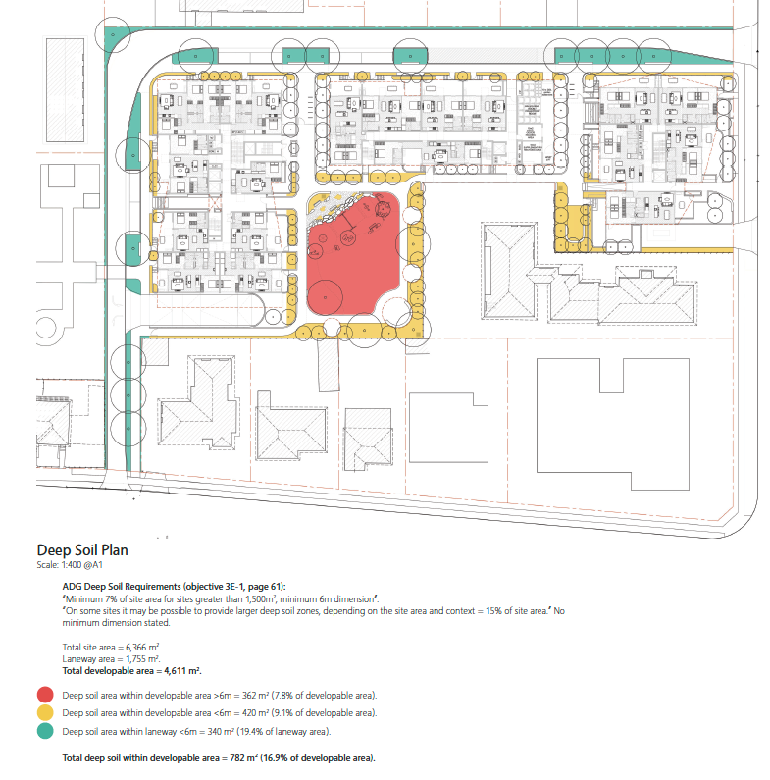
Figure 7 – Deep Soil Plan (source Matthew Pullinger Architect, Studio Hollenstein)
The updated Landscape Plan also provides additional input about Soil depth and type for planting over structures, which shows a minimum soil depth of 900mm. It is acknowledged that the basement does not sit exclusively under the buildings with the exception of through connections. This was explored by the applicant and not found to enable significant additional deep soil and would fundamentally reduce the functionality of the basement. Given that the proposal meets the requirements of the ADG for deep soil, and delivers significant landscaped area throughout the precinct, retaining the existing proposed basement layout was deemed acceptable to optimise its functionality and reduce its overall size.
The amended landscape plans have also outlined how the proposal complies with the dimension requirements for landscaping at the ground floor. In particular, the landscape plan shows a consolidated communal area of over 900. Whilst one of the dimensions is less than 28m (26.3m), the other dimension is 32.2m and provides a consolidated site of 912sqm. As shown on the figure below, the proposal delivers generous landscaping and deep soil areas that are broadly consistent with the numerical standards whilst meeting the objectives and intent of the controls. The amended landscape plan also outlines the amended proposed plants who are largely native and durable species.
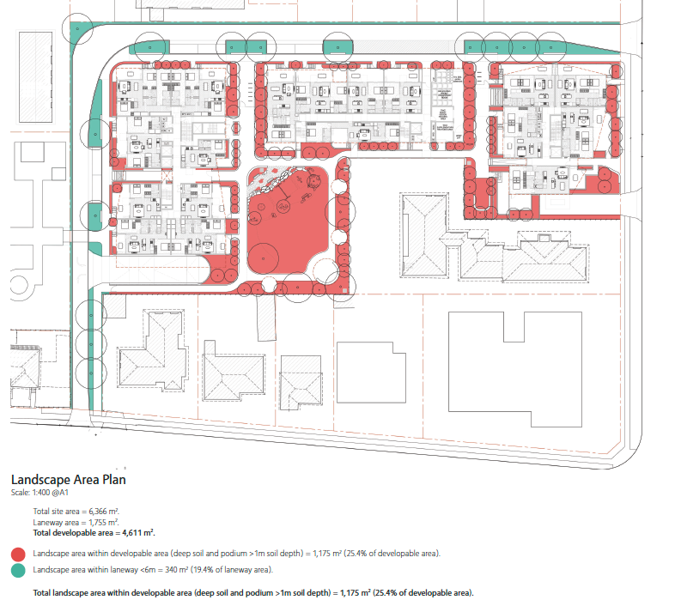
Figure 8 – Landscape Plan (source Matthew Pullinger Architect, Studio Hollenstein)
Referrals
The application was referred to the relevant external and internal stakeholders. Their
comments are outlined within the table below:
External Referrals |  | Comments Received
WaterNSW (pursuant to Section 91A of the Environmental Planning and Assessment Act 1979) |  | Terms of Approval provided.
Sydney Trains |  | No objections – subject to conditions that have been provided.
Ausgrid |  | Ausgrid advised that no comments were required. They made no objection to the substation.
Internal Referrals | Comments Received
Infrastructure Engineer | No objection subject to conditions.
Asset Planning - Stormwater | No objection subject to conditions, in particular as it relates to Council’s existing stormwater asset at the north-west corner of the site  - Stormwater – Existing Council Drainage Infrastructure – The proposed Building C and new laneways are in close proximity to the existing Council drainage infrastructure (1.35 m diameter RCP and 2.51 m x 1.22 m Tonkin pipe). There are no existing easements over these pipes.  Council’s stormwater team has proposed appropriate conditions to manage these existing pipes and any need for future works to be undertaken by Council.
Urban Design | Concerns remain around certain areas of landscape and built form including building separation, length and street walls. From an overall evaluation of the proposal against the relevant State and local controls, the development, as amended, is considered an acceptable outcome for the site. Refer above in the report for discussion these issues under SEPP 65, LEP and DCP controls.
Landscape Architect | Concerns remaining around certain areas of landscape, deep soil and basement extent. Refer above in the report for discussion on these issues. Overall landscape design represents a reasonable treatment of a site of this scale and density and is generally consistent with the required local and state planning controls.
Traffic | No objection, subject to Conditions.
Resource Recovery (Waste) | No objections raised, subject to conditions
Development Engineer | No objections raised, subject to conditions
Environmental Health Officer | No objections raised, subject to conditions
Community Safety Officer | Due to the size and scale of the development the below community safety recommendations were made;  - A comprehensive and detailed Plan of Management (PoM) is to be provided by the applicant. This document should address CPTED principals, security and general aspects of community safety.  - The most current Statement of Environmental Effects (SEE) does not detail CPTED principals, at a minimum these should be addressed due to the size of the development.  These documents were submitted and considered adequate to address matters of community safety and design and are discussed earlier in this report.  The proposal to remove the boundary fence between the site and the eastern adjoining Jubilee Park is acceptable provided landscaping is established as a visual buffer between the two.
Parkes and Gardens | Have raised concerns about the proposed removal of the dividing fence between the site and the adjoining Jubilee Park, for overland flow and flood mitigation. However, as the fence will be replaced with suitable landscaping, this is consider a reasonable barrier between the sites.
Building Surveyor | No objections raised, subject to conditions
Heritage | The proposal, is not likely to affect the signficance of the station and the associated significant built fabric, nor impact on its location, placement and prominence within the streetscape.  Having regard to the comments above, the proposal is considered acceptable from a heritage point of view.
Fire Safety Officer | No objections raised, subject to conditions

Canterbury Development Contributions Plan 2013 (Contributions Plan 2013)
Based on Rev C architectural plans dated 16 May 2022, the three proposed RFBs contain a total of 144 units (7 x studios; 12 x 1 bedroom units; 109 x 2 bedroom units and 16 x 3 bedroom units). While the existing site does not contain any existing residential accommodation that can be offered as a credit in calculating the s7.11 contributions, the site is subdivided into three lots (capable of supporting 3 dwellings) and a credit for those lots (ie: 3 x 3 bedroom dwellings) can be given.

DIMENSIONS USED:

What is the estimated cost of development? | 43339324
How many total lots are being created? | 2
CCC 2013 PLAN - RESIDENTIAL DWELLINGS | 0
How many proposed 1 Bed/Studio | 19
How many proposed 2 bedroom dwellings | 109
How many proposed 3 or more bedroom dwellings | 16
How many existing 3 or more bedroom dwellings | 3

CONTRIBUTION FEE CALCULATION:

Community Facilities | $182,980.12
Open Space and Recreation | $1,788,476.60
Plan Administration | $51,494.93
TOTAL | $2,022,951.65

Planning agreements [section 4.15(1)(a)(iiia)]

The land is subject to a Voluntary Planning Agreement (VPA), which was executed with the Council on 12th June 2020. The development must be consistent with the requirements of the VPA or they must negotiate any changes to the VPA separately.

The regulations [section 4.15(1)(a)(iv)]

The proposed development is consistent with the relevant provisions of the Environmental Planning and Assessment Regulation, 2021.
The likely impacts of the development [section 4.15(1)(b)]
Majority of the potential acoustic impacts have been discussed within the relevant sections of the report above. In addition to the matters discussed, the potential acoustic impacts of the new rear laneway, driveway and loading dock on the residential within the site as well as on adjoining sites has been considered.
Acoustic Impacts
The application was accompanied by an Acoustic Report, which demonstrates that, subject to appropriate design treatments, noise impacts from surrounding areas including trains and vehicular traffic can be managed. These conditions include:
- Glazed windows and doors;
- Entry door treatments;
- Appropriate roof and ceiling insulation;
- External wall insulation and construction; and
- Supplementary ventilation systems, if needed to ensure ventilation even where doors and windows are closed.
National Construction Code
Council’s Building Surveyor has reviewed the application and raises no objection, subject to conditions of consent.
Proposed excavation works
The proposed development involves excavation and construction works in close proximity to property boundaries and neighbouring properties. Should the application be approved, relevant conditions requiring the applicant to provide a dilapidation report for the adjoining properties, prior to the issue of the Construction Certificate have been included in the draft conditions of consent issued. Should any damage to adjoining properties result from the proposed excavation works at the subject site, the applicant would be required to rectify all damages.
Sediment and Erosion Control
Standard conditions could be included regarding the installation and maintenance of the sediment and erosion control measures as part of the pre and during construction phase of the development, should the application be supported.
The development will involve excavation of part of the site to accommodate the development. Any excavated material not utilised elsewhere on the property, will require proper disposal and transport in accordance with the Waste Avoidance and Recovery Act, and the Protection of the Environment Operations Act. A condition could be imposed in this regard should the application be supported.
Suitability of the site [section 4.15(1)(c)]
The proposed development is permitted with consent on the subject site and represents a built form that is compatible with the existing and future character of the locality. The application has been assessed under Section 4.15 of the Act, and as demonstrated throughout the body of this report, the proposal generally complies with the relevant development controls. The proposed variations to the relevant ADG, CLEP 2012 and CDCP 2012 controls regarding deep soil, visual privacy, front setbacks and building depth have been assessed on merit and are acceptable for the reasons outlined within the body of the report.
Submissions [section 4.15(1)(d)]

The application was advertised for a period of 28 days in [insert dates] and [insert dates]. 5 objections were received during this period, which raise concerns relating to the issues outlined and responded to below.

Objection: Neighbouring dwellings should not lose natural light.
Comment: Whilst the development does reduce solar access to some dwellings, it is compliant with the solar access requirements of the Apartment Design Guide. In addition, the proposed development complies with the maximum building FSR and height controls and is therefore a reasonable scale of a development permitted in that location. It is also noted that as the massing and setbacks to residential properties are consistent with the planning controls, then the level of impact would have already been considered acceptable in the formulation of the controls.

All north facing living rooms of 11 Croydon St, which is most affected by the proposal, still retain 2 hours of solar access between 9am-3pm. Similarly, the properties along Railway Parade also continue to achieve solar access to their private open space and living area windows.

Objection: The new development will look directly into adjacent units and yards will impact on privacy.
Comment: The building has been designed to minimise overlooking to adjacent units with separation distances generally compliant with the Apartment Design Guide, and apartment layouts and window locations designed to minimise direct overlooking.
The development footprints are generally consistent with the DCP envelope and setback controls. The north facing dwellings are significantly separated from residential development to the north by the future laneway, and comply with the required Apartment Design Guide building separation requirements. As shown in the Figure below, to the north, the future controls anticipate an 18m building height (5-6 storeys), and a 3m setback requirement. As such, the proposed development is adequately separated from the future development to the north, as demonstrated in both the DCP and ADG controls.
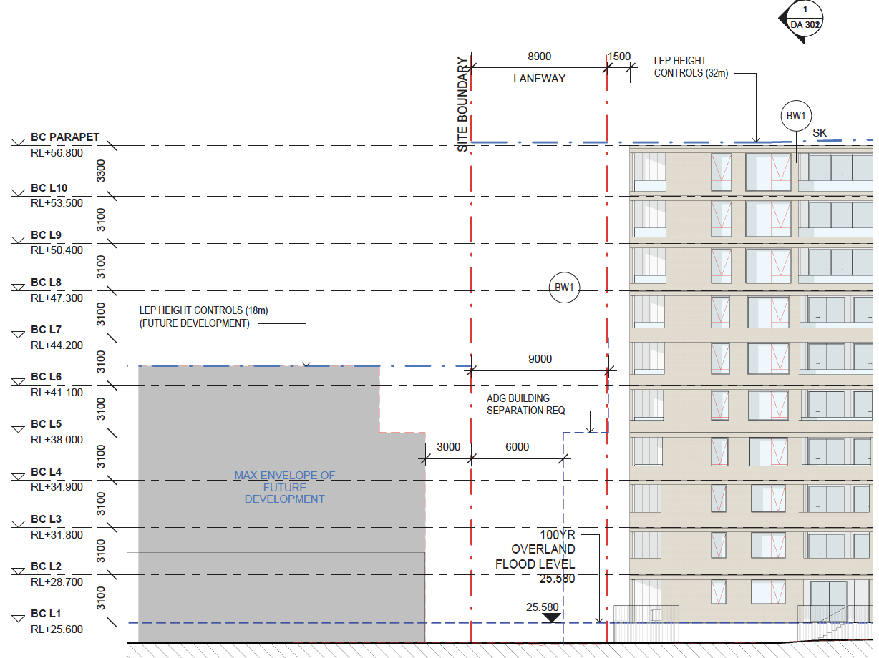
Figure 9 – Building Separation Figure (source Matthew Pullinger Architect, Studio Hollenstein)
With respect to the developments to the south of the site, these are all lower-scale developments only requiring a maximum 12m separation under the ADG. The proposal generally meets this requirement. In addition, amendments have been made to include blinkered windows to address any overlooking of adjacent apartments and communal spaces so that separation is not the only control to protect visual privacy.

Objection: The proposal should not exceed the current zoning limits and should comply with the maximum 5/6 storey height limit.
Comment: The zoning and maximum height of buildings for the site has been set by the Planning Proposal which amended the Canterbury LEP. The proposal is fully compliant with the LEP height and FSR controls.

Objection: The development should create green space where children can play and landscaping to reduce the urban heat island effect.
Comment: Agree. The development includes communal open space for residents which includes a children’s play space. The site is also located directly adjacent to a local park and will enhance accessibility and safety of the park. A landscaping plan has been prepared which identifies street trees and landscaping / green cover within the development to provide shade and mitigate urban heat.

Objection: The development is not in keeping with the with the surrounding development.
Comment: Whilst the intensity of the proposed development is greater than developments currently surrounding it, the precinct went through a detailed design and planning process to provide new LEP and DCP controls that reflect the growth in an area in good proximity to the Lakemba train station. Other sites have gone through a rezoning process to provide appropriate transition and diversity of density in the precinct.
The development has been designed to deliver high quality design which responds to the surrounding building form character and is consistent with the height and built form controls specified for the site in the Canterbury LEP. The materials, particularly the dark and light brick have been chosen to reflect the historic materiality and character of Lakemba.

Objection: Concern was raised about noise impacts of the development.
Comment: A noise assessment was prepared as part of the SEE which included a noise emission assessment to ensure that the noise emissions from the development are in accordance with relevant criteria to ensure that the amenity of surrounding uses is maintained, including a Plan of Management for the rooftop communal area.

Objection: Concern was raised about increased traffic and parking congestion from the development.
Comment: A traffic study was prepared that included traffic modelling demonstrating the new development would have minimal impact on the performance of the surrounding road network. Parking has been provided in accordance with the RMS rates for traffic generating development given its close proximity to the train station. The development will also include visitor spaces to minimise parking impacts on the local road network.

Objection: Concern was raised about the need for better public transport, bus shelters, pedestrian and cycle paths and trees for shade.
Comment: The site is well located in close proximity to public transport. A new local street is also being provided which will enhance connectivity and pedestrian / cycle accessibility and includes street trees and landscaping to provide shading and enhanced amenity as shown in the Landscape Plans. Upgrades to the wider public transport / active transport network is being considered by Council and TfNSW separate to the development consent process.
The public interest [section 4.15(1)(e)]
The proposed development would not contravene the public interest. The development appropriately responds to the applicable environmental instruments and development controls, and the proposed development would contribute to housing diversity within the Canterbury-Bankstown LGA.
CONCLUSION
The Development Application has been assessed in accordance with the provisions of Section 4.15 of the Environmental Planning and Assessment Act 1979, Canterbury Local Environmental Plan 2012 and Canterbury Development Control Plan 2012.
The proposed variations to the controls relating to building height and setbacks, visual privacy (building separation), front setbacks and building depth will not result in any significant adverse impact on the amenity of future occupants of the site as well as existing residents on adjoining properties. The design of the proposed development is compatible with the future and desired local character of the area and represents a quality development that will positively contribute to the streetscape and the local built environment. As such, it is recommended that the development application be approved subject to conditions of consent.

RECOMMENDATION
It is recommended that the application be approved subject to the attached conditions.

